

**Synthetic plants for a sustainable future**

**Programme Thesis**

v1.0

**Angie Burnett, Programme Director**

# **CONTEXT**

This document presents the core thesis underpinning a programme that is currently in development at ARIA. We share an early formulation and invite you to provide feedback to help us refine our thinking.

Sign up at [www.aria.org.uk/opportunity-space-updates/](https://www.aria.org.uk/opportunity-space-updates/) to receive all updates about this opportunity space and see the programme at [www.aria.org.uk/synthetic-plants](https://www.aria.org.uk/synthetic-plants)

**An ARIA programme seeks to unlock a scientific or technical capability that**

* changes the perception of what’s possible or valuable
* has the potential to catalyse massive social and economic returns
* is unlikely to be achieved without ARIA’s intervention

# **PROGRAMME THESIS, SIMPLY STATED**

*A summary capturing the evolution of our thinking since publication.*

Since publishing this thesis in June 2024, we have invited public feedback on our ideas and engaged with experts to challenge and refine our thinking. As a result, this thesis has been updated to reflect the latest thoughts on the programme structure.

* To maximise the potential for the sharing of technical advances, work in Phase One will focus on a single crop species, potato (Solanum tuberosum), with expansion to additional species (including a monocot) in Phase Two. An explanation of why this was chosen has been added to the ‘What we expect to fund’ section.
* Table 2 and Figure 3 have been updated to reflect our latest thinking on how the technical areas will be distributed across the phases, along with the key tasks and metrics of success associated with each technical area.

# **PROGRAMME THESIS, SIMPLY STATED**

*This programme thesis is developed from the ARIA opportunity space* **Programmable Plants – A technology platform for sustainable abundance**, *which can found at* [*www.aria.org.uk/what-were-working-on/#angie*](http://www.aria.org.uk/what-were-working-on/#angie)

Plants are the foundation of our food system, and are indispensable providers of fuels, fibres and pharmaceuticals. Representing 450 Gt of global carbon, plants are a critical and underutilised lever for solving the combined challenges of climate change and food security. While plants today can be functionalized and cheaply produced at global scale, the diversity and utility of engineered plants are highly limited. Synthetic biology can open up extraordinary new possibilities.

Fully synthetic plants - with genomes written from scratch - could deliver an abundance of products and services sustainably, from food to materials, medicine, and beyond. A critical first step is developing the building blocks for synthetic plant genomes: genetic units in the nuclei and organelles of plant cells.

This programme aims to design, build, deliver and maintain synthetic chromosomes and chloroplasts that are viable in a living plant. Our ability to do so is now at the edge of what is possible; a successful programme would not just demonstrate a critical step on the path to fully synthetic plant genomes but in itself enable our major crops to be more productive, resilient and sustainable. This programme will therefore unite expertise in synthetic biology and plant biology to catalyse the next generation of plant synthetic biology, unlocking new capabilities of plants to meet the future needs of humankind.

*“Imagine designing a genome that would have benefits that are not currently present in Mother Nature” –* Quote from Discovery Process

# **PROGRAMME THESIS, EXPLAINED**

*A detailed description of the programme thesis, presented for constructive feedback.*

**Why this programme**

Why synthetic biology in plants?

Synthetic biology is revolutionising the world of healthcare with novel approaches to drug production, CRISPR therapeutic treatments and the advent of personalised genomics. The use of synthetic biology has centred around health rather than agriculture [1], yet it has the potential to transform the agricultural industry - an enormous global market predicted to amount to over £3 trillion gross production value in 2024 [2]. This presents a huge missed opportunity, considering the diversity of services provided by plants and the scope for impact across vast arenas from food to pharmaceuticals and beyond.

The goal of this programme is to develop synthetic genetic units (specifically, synthetic chromosomes and synthetic chloroplasts), that are viable in a living crop plant and add currently unattainable functions [3, 4]. This technology will ultimately enable plants to provide numerous benefits for future generations. In the agricultural context, this may include the following (Table 1):

| Functionality | Benefit |
| --- | --- |
| * fortification with essential nutrients | * boosting human health |
| * fixation of nitrogen from the atmosphere | * reducing reliance on environmentally costly fertilisers |
| * alternative photosynthetic pathways that are more water efficient | * reducing agricultural water use |
| * perenniality | * reducing tilling, thereby improving soil health |
| * additional carbon sequestration | * removing carbon dioxide from the atmosphere to mitigate climate change |
| * resilience to environmental stresses, pests and pathogens | * protecting crop yields in uncertain conditions |
| * synthesis of novel compounds and utilisation of naturally occurring molecules in plants | * providing fuels, pharmaceuticals, materials and other beneficial products |

Capabilities that will be sparked by this programme

This programme will serve as a catalyst for future innovations in two major ways. The initial intrinsic value unlocked by this programme will be (1) the generation of synthetic units that can be integrated into plants to introduce rationally designed functionalities that are valuable in their own right. Demonstrating that a functioning synthetic unit is possible will pave the way for (2) the development of a greater number and diversity of synthetic units delivering a wider range of benefits beyond those developed in the programme, and (3) the development of fully synthetic genomes in plants and the delivery of new-to-nature capabilities.

Success in this programme will enable us to move beyond what can be accomplished with gene editing, empowering us to imbue plants with entirely new suites of functionality. A functioning synthetic unit can provide advances such as enhancing yield and stress resilience at scale, generating multi-purpose crops, and upgrading under-utilised crop species to boost their productivity and bring them up to speed with major crops, adding diversity and elasticity to our agricultural systems and maximising nutritional benefits.

We expect to see technical innovations in the assembly of synthetic units, delivery of genetic material into plant cells, recoding of plant genes, advanced multicellular synthetic genetics and functional breakthroughs in crop traits.

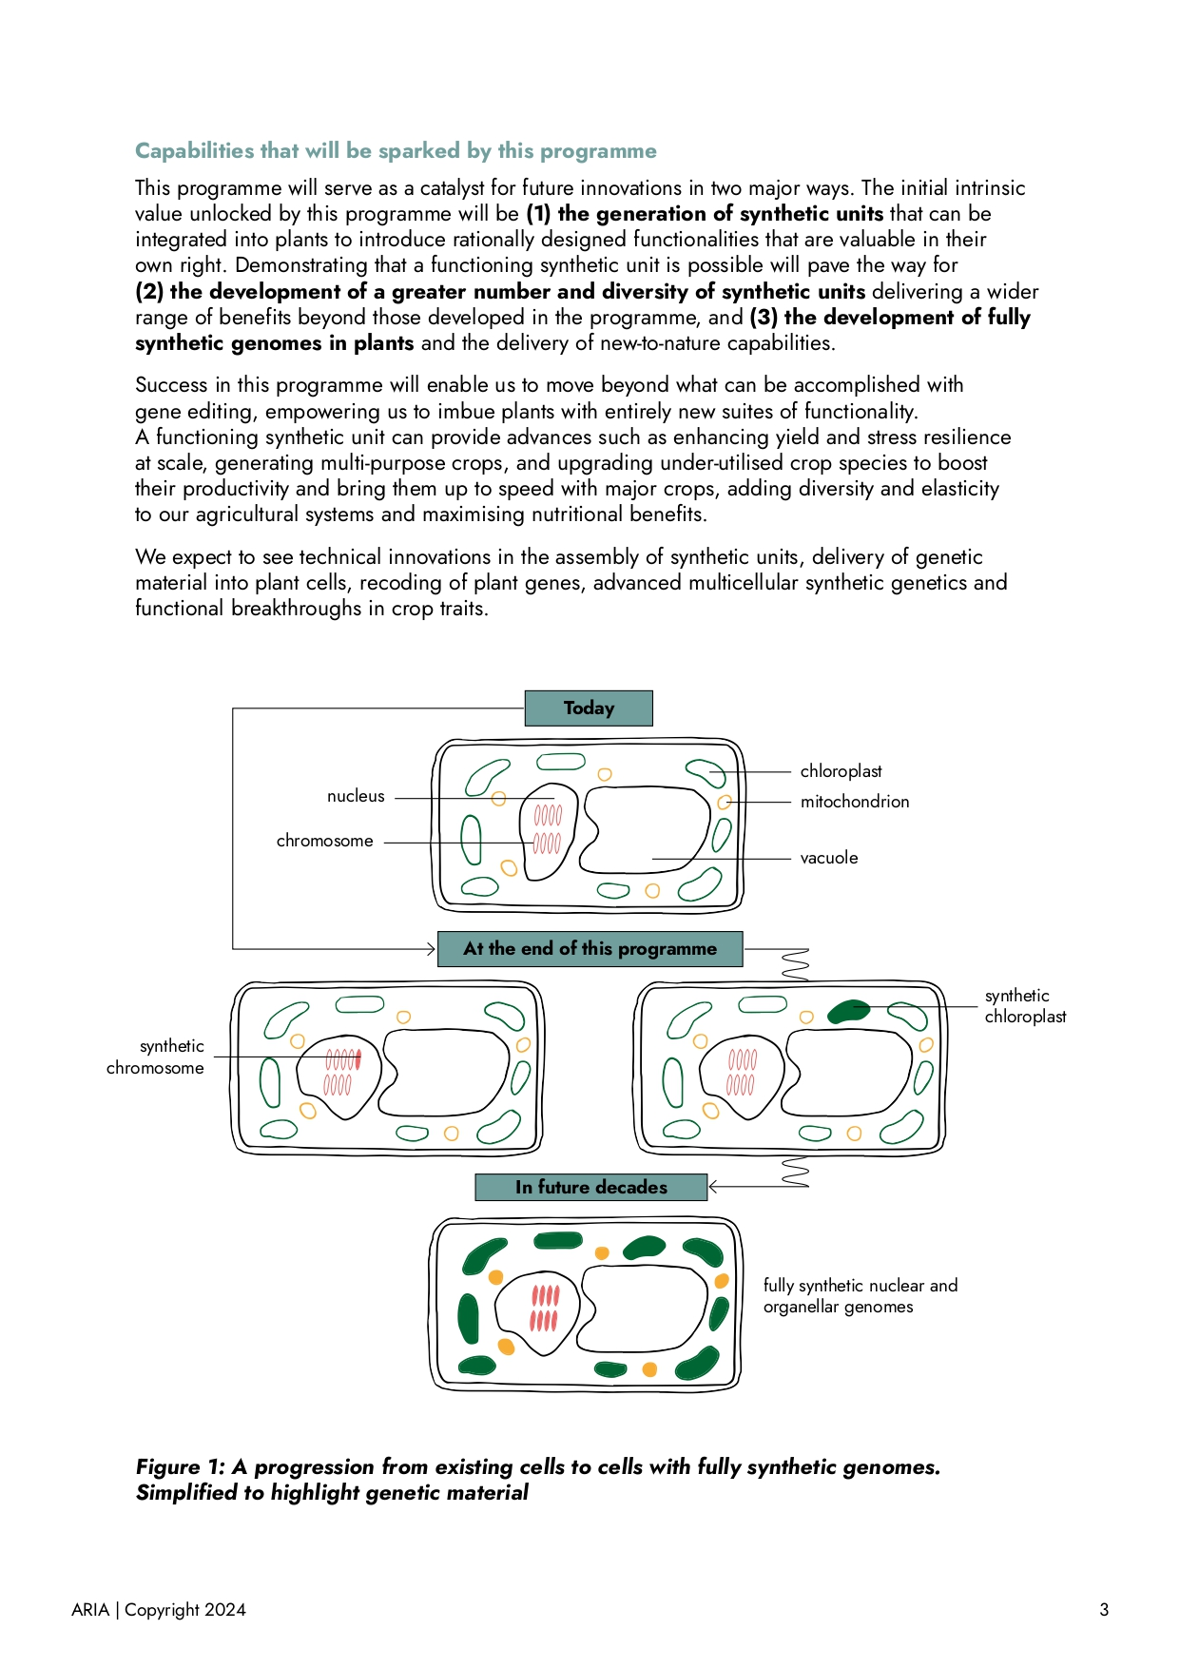

**Figure 1: A progression from existing cells to cells with fully synthetic genomes. Simplified to highlight genetic material**

*Figure 1 is an image portraying the progression from existing cells to cells with fully synthetic genomes. It has been simplified to highlight genetic material. In each case, a plant cell with vacuole, nucleus, nuclear chromosomes, chloroplasts and mitochondria is shown. Today: there are no synthetic genetic elements. At the end of this programme: two cells are shown, one with a shaded nuclear chromosome to indicate a synthetic chromosome and one with a shaded chloroplast to indicate a synthetic chloroplast. In future decades: all nuclear chromosomes, chloroplasts and mitochondria in the cell are shaded to indicate a fully synthetic plant genome.*

| Key definitions  Synthetic chromosome – a nuclear chromosome composed of nucleic acids, that has been artificially synthesised *de novo* rather than assembled naturally. In this document, ‘synthetic chromosome’ refers exclusively to bottom-up synthetic chromosomes i.e. totally synthetic chromosomes; it does not refer to top-down synthetic chromosomes which are made by altering existing chromosomes.  Synthetic chloroplast – a chloroplast that has a fully synthetic genome (a genome that is artificially synthesised rather than assembled naturally). The chloroplast is not necessarily entirely synthetic (i.e. the chloroplast itself does not need to be assembled artificially rather than naturally).  Synthetic genome – a genome that has been artificially synthesised rather than assembled naturally.  Synthetic unit (or synthetic genetic unit) – refers to either a synthetic chromosome or synthetic chloroplast. This term is used throughout this document for the sake of conciseness. |
| --- |

*See “Appendix I: The potential of synthetic biology” for a deeper dive into the past, present and future of genome synthesis. See “Appendix II: Why plants?” for the particular use case and scope of plants.*

**What we expect to fund**

The programme will create synthetic genetic units in plant cells. The synthetic unit could be a (minimal) synthetic chromosome, or a (minimal) synthetic chloroplast. These two possibilities for a synthetic unit could also be combined with co-design of nuclear and chloroplast engineering in a parallel approach. We will fund research into the following key actions required for developing a synthetic unit (Figure 2):

* Design the unit (including development of regulatory switches for controlling the unit)
* Build the unit
* Deliver the unit (including development of novel methods for transferring units into cells)
* Maintain the unit in the cell
* Species Transferability of the unit
* Trait Complexity delivered by the unit
* Social and Ethical considerations

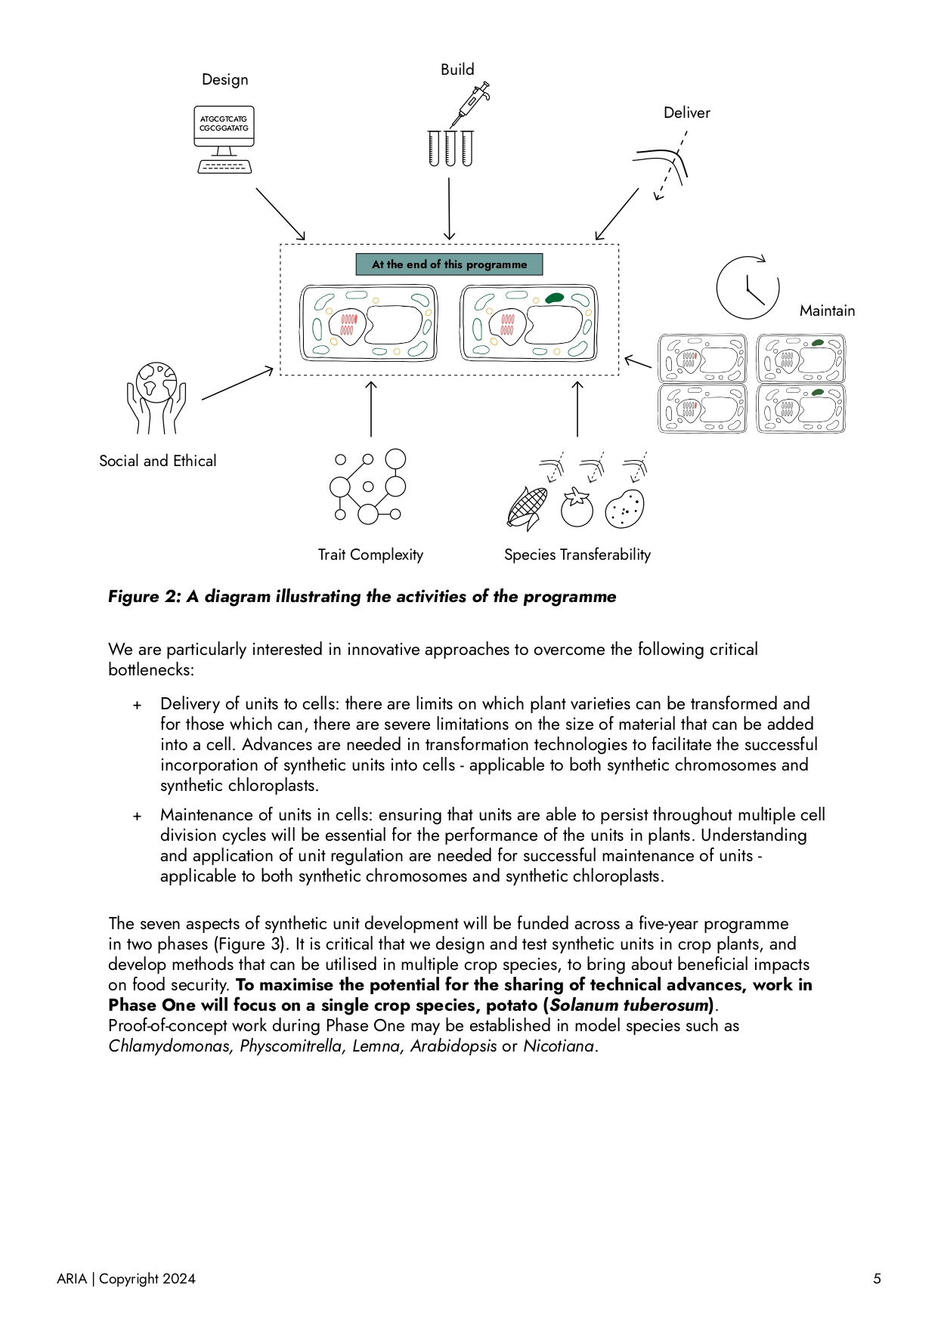

**Figure 2: A diagram illustrating the activities of the programme.**

*At the centre are cells from "at the end of this programme" in Figure 1. Around these cells, with arrows pointing inwards, are the following vignettes: Design, with a computer showing genetic code; Build, with a Gilson pipette and test tubes; Deliver, showing transfer across a cell wall and cell membrane; Maintain, showing cells with synthetic units and a clock icon indicating maintenance over time; Species Transferability, with the deliver icon associated with multiple crop species; Trait Complexity, with a complex molecular structure; Social and Ethical, with an image of planet earth held between two hands.*

We are particularly interested in innovative approaches to overcome the following critical bottlenecks:

* Delivery of units to cells: there are limits on which plant varieties can be transformed and for those which can, there are severe limitations on the size of material that can be added into a cell. Advances are needed in transformation technologies to facilitate the successful incorporation of synthetic units into cells - applicable to both synthetic chromosomes and synthetic chloroplasts.
* Maintenance of units in cells: ensuring that units are able to persist throughout multiple cell division cycles will be essential for the performance of the units in plants. Understanding and application of unit regulation are needed for successful maintenance of units - applicable to both synthetic chromosomes and synthetic chloroplasts.

The seven aspects of synthetic unit development will be funded across a five-year programme in two phases (Figure 3). It is critical that we design and test synthetic units in crop plants, and develop methods that can be utilised in multiple crop species, to bring about beneficial impacts on food security. **To maximise the potential for the sharing of technical advances, work in Phase One will focus on a single crop species, potato *(Solanum tuberosum)***with expansion to additional species (including a monocot) in Phase Two. Potato has been selected for both social and scientific reasons: it is a crop of social and economic importance, and it is comparatively easy to transform. The specific variety of potato to be used will be determined in consultation with all creators at the beginning of the programme. Proof-of-concept work during Phase One may be established in model species such as *Chlamydomonas, Physcomitrella, Lemna, Arabidopsis* or *Nicotiana.*

During the early stages of Phase One, a range of possible delivery techniques for both synthetic chromosomes and synthetic chloroplasts will be tested, and the potential for cross-species transferability will be assessed. Delivery techniques with the highest potential for cross-species transferability will be selected as the focus methods for the remainder of Phase One. Establishing the units in multiple food crop species such as tomato, canola, wheat, barley and maize is an essential element of Phase Two.

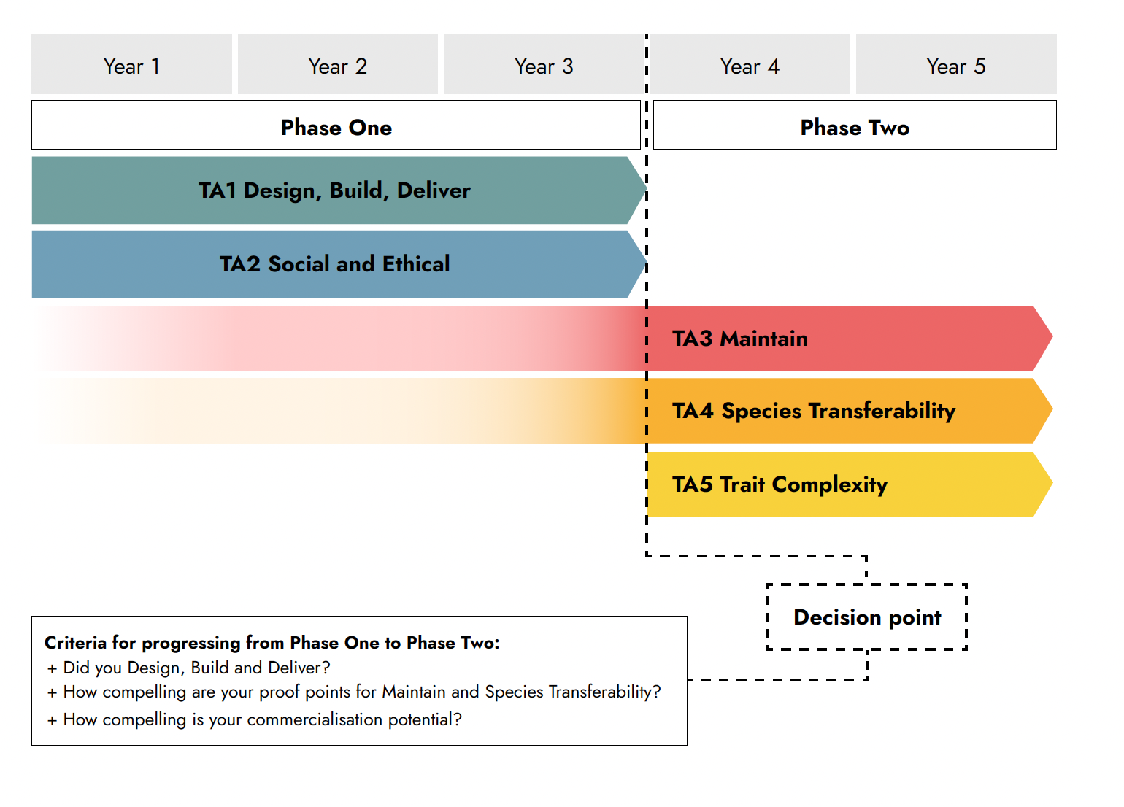

**Figure 3: A depiction of the different phases of the programme.**

*Phase One (years 1-3) contains Design, Build, Deliver, Maintain, Species Transferability, Social and Ethical. Phase Two (years 4-5) contains Maintain, Species Transferability and Trait Complexity. Between the two phases, there are the following criteria for the decision point. Did you Design, Build and Deliver?; How compelling are your proof points for Maintain and Species Transferability?; How compelling is your commercialisation potential?*

For the programme taken as a whole, the key measure of success will be the development of a synthetic chromosome and/or a synthetic chloroplast that can be maintained inside a plant, adds a complex trait, and can be viable in multiple crop species of socioeconomic value.

For Phase One, the key measure of success will be the successful delivery of a synthetic unit into a living plant cell. For Phase Two, the key measures of success will be the maintenance of a synthetic unit in living plants, of three different agriculturally relevant species, in each of which the synthetic unit delivers a complex trait. The specific nature of the complex trait is not a predefined element of the programme.

For each individual or team working on the programme, success will be measured depending on the aspect(s) of the programme being worked on and metrics will be set accordingly. These could include the building of a synthetic chromosome inside a plant cell, the development of a novel method for insertion of DNA into a plant cell, or the analysis of a comprehensive public engagement activity leading to a concrete understanding of public opinion around the programme.

Work on designing, building, delivering and maintaining the synthetic unit will take place in parallel. By working on each of these aspects simultaneously, the programme will not only iterate more rapidly and more effectively in each area, but will also develop core capacities in multiple areas that are not contingent upon one another. This lack of dependency will enable meaningful progress to be made even if the overall objective of the programme is not met.

We believe that taking multiple approaches to tackle the work outlined in this programme will be the most effective way to make progress, and we are willing to fund novel and high-risk approaches to the work. We believe that successes on the path towards the milestones in this programme will enable us to solve other open questions in synthetic biology and plant biology, and to bring benefits to both disciplines reaching beyond the scope of this programme.

Table 2 indicates key tasks and metrics of success that we envisage will be necessary for each aspect of unit development:

| Technical Area (TA) | Key tasks | Metrics of success |
| --- | --- | --- |
| TA1  Design, Build, Deliver | TA1.1 Design   * Initially, developing multiple designs for units that deliver a simple trait * Subsequently, refining designs to improve trait delivery and to make necessary amendments based on the results of Build/Deliver * Development and testing of engineered biological ‘switches’ for turning units on and off *in vivo* (including a consideration of nuclear genes, for the chloroplast workstream) * Consideration of recoded genome approach for genetic isolation   TA1.2: Build   * Synthesising DNA * Assembling large pieces of DNA * Testing viability of designed unit *in vitro* * Building units *in vitro* and *in vivo*   TA1.3 Deliver   * Developing and testing multiple delivery methods for inserting units into cells * Developing and testing assembly of units inside cells as an alternative to delivering assembled units * Developing and testing selection procedure for transformed organisms * For synthetic chromosomes: delivery of 1 Mb DNA into cell * For synthetic chloroplasts: delivery of 100-150 kb DNA into chloroplast within cell | TA1.1 Design   * Unit design delivers specified trait * Unit activity is regulated *in vivo* with at least the same level of nuance as in a natural occurrence of the trait   TA1.2: Build   * Unit is viable *in vitro* * Unit is viable and functional *in vivo* with at least the same level of functionality as in a natural occurrence of the trait   TA1.3 Deliver   * Unit can be inserted into or assembled inside cells with >5% success rate * Transformed organisms can be selected rapidly and accurately, with a greater throughput for identifying transformants than is currently possible in tissue culture |
| TA2  Social and Ethical | * Studies of the possible opportunities and projected implications of synthetic plants (including advantages and disadvantages) for a range of stakeholders including farmers, industry supply chains, governance stakeholders and public * Review of ethical issues around synthetic plants * Public engagement to understand public opinion on synthetic plants and engage with public concerns, including understanding which of the proposed benefits of synthetic plants are considered credible and acceptable, and under which circumstances | * Diverse stakeholders engaged * Ethics roundtable held and outcomes published in public domain * 5 public engagement activities carried out (including surveys and workshops) |
| TA3  Maintain | * Initially, considering what is necessary for maintenance and replication of the unit within the cell, and prototyping in this area * Subsequently, ensuring maintenance and replication of the unit within the cell * Testing the functionality of the unit within the cell * Development of appropriate biological containment methods for the unit | * Unit replicates inside the cell * Unit remains stable, viable and functional after 5 cell divisions with the same level as functionality as prior to cell division * Plant growth rate is not significantly lower than in equivalent plants without the synthetic unit |
| TA4  Species Transferability | * Demonstrate that the unit functions in multiple species | * Unit functions in three major crop species including one monocot and one dicot |
| TA5  Trait Complexity | * Successfully deliver an agriculturally relevant complex trait using the synthetic unit | * Unit delivers a complex trait that could not readily be introduced by breeding or gene editing |
| Overall | * Develop synthetic unit in crop plants | * Synthetic unit functions and is maintained in three major crop species, delivering a complex trait that could not readily be introduced otherwise |
| TA1  Design, Build, Deliver | TA1.1 Design   * Initially, developing multiple designs for units that deliver a simple trait * Subsequently, refining designs to improve trait delivery and to make necessary amendments based on the results of Build/Deliver * Development and testing of engineered biological ‘switches’ for turning units on and off *in vivo* (including a consideration of nuclear genes, for the chloroplast workstream) * Consideration of recoded genome approach for genetic isolation   TA1.2: Build   * Synthesising DNA * Assembling large pieces of DNA * Testing viability of designed unit *in vitro* * Building units *in vitro* and *in vivo*   TA1.3 Deliver   * Developing and testing multiple delivery methods for inserting units into cells * Developing and testing assembly of units inside cells as an alternative to delivering assembled units * Developing and testing selection procedure for transformed organisms * For synthetic chromosomes: delivery of 1 Mb DNA into cell * For synthetic chloroplasts: delivery of 100-150 kb DNA into chloroplast within cell | TA1.1 Design   * Unit design delivers specified trait * Unit activity is regulated *in vivo* with at least the same level of nuance as in a natural occurrence of the trait   TA1.2: Build   * Unit is viable *in vitro* * Unit is viable and functional *in vivo* with at least the same level of functionality as in a natural occurrence of the trait   TA1.3 Deliver   * Unit can be inserted into or assembled inside cells with >5% success rate * Transformed organisms can be selected rapidly and accurately, with a greater throughput for identifying transformants than is currently possible in tissue culture |

We expect to fund a larger number of projects in Phase One, of which a subset will continue into Phase Two (Table 3):

| Synthetic Unit | Projects in Phase One | Projects in Phase Two |
| --- | --- | --- |
| Chromosome | 1-3 | 1-2 |
| Chloroplast | 1-3 | 1-2 |

We are interested in funding individuals and teams with expertise in plant biology and/or synthetic biology from a variety of sectors and disciplines: cell biologists, biochemists, molecular biologists, geneticists, plant biologists, plant synthetic biologists, non-plant synthetic biologists, systems biologists, social scientists and ethicists, and are particularly interested in teams that are bringing a new lens or perspective on what is possible or how to approach the bottlenecks described above. Individuals and teams working on the programme will participate in regular in-person gatherings and virtual meetings to enable the sharing of updates and the generation of new ideas to shape the programme. There will be frequent milestones that will need to be met throughout the life of the programme.

# **ENGAGE**

*Our next step is to launch a funding opportunity derived or adapted from this programme formulation. Click* [***here***](https://wkf.ms/3Ri0SjQ) *to register your interest, or to provide feedback that can help improve this programme thesis.*

# **APPENDIX I: THE POTENTIAL OF SYNTHETIC BIOLOGY**

*Included as a primer for plant scientists for whom the field of genome synthesis may be new.*

Why strive for a synthetic plant genome?

Synthetic genomes offer multiple benefits. They allow the creation of novel compounds and molecules that can act as pharmaceuticals and building materials that can be grown in plants rather than synthesised in a lab. They enable the development of organisms that are new-to-nature and capable of thriving in future climates or even mitigating climate change. For example, synthetic photosynthetic pathways can be used to dramatically increase carbon capture [5].

When writing synthetic genomes, compared to when editing existing genomes, codon compression and expansion can lead to a new genetic code which is able to fulfil existing functions more efficiently, or fulfil novel functions more readily. By using a new genetic code, genetic isolation is possible, providing in-built biocontainment of synthetic organisms[6]. Minimal genomes can provide reduced complexity, lowered energetic costs and greater biosynthetic capacity [3]; a synthetic chromosome fragment in moss was recently reduced by >50% with no phenotypic effect [7]. This programme will generate the building blocks needed for creating synthetic plant genomes in the future.

There are many challenges to overcome in assembling and delivering synthetic genome elements, such as chromosomes, into plants [8]. Synthetic chromosomes and synthetic chloroplasts are two options for delivering gene modules. These synthetic units, the focus of this programme, are highly valuable in their own right and also serve as steps towards fully synthetic genomes that will unlock even greater possibilities in the future.

Genome synthesis: the state of the art

Synthetic yeast and human chromosomes are being developed, and a synthetic chromosome fragment has been introduced into moss, but the development of functional synthetic chromosomes or chloroplasts delivered into higher plants including crops is still unattainable. This is partly due to the challenges of working with plants compared to other organisms, such as underdeveloped transformation protocols and long generation times, and partly due to the under-investment into plant synthetic biology compared with other areas of life sciences.

This programme will generate novel transformation methods to turbocharge the field of plant genomics and will leverage advances in plant biology, synthetic biology and genetics - to develop synthetic units in crop plants, using a diversity of disciplines to generate and test novel solutions on the journey to synthetic plant genomes.

Recent advances in chromosome and chloroplast engineering mean that the time is ripe for a concerted effort across disciplines and approaches: to develop synthetic plant components delivering valuable benefits and ultimately enabling us to move towards synthetic plants with new-to-nature capabilities.

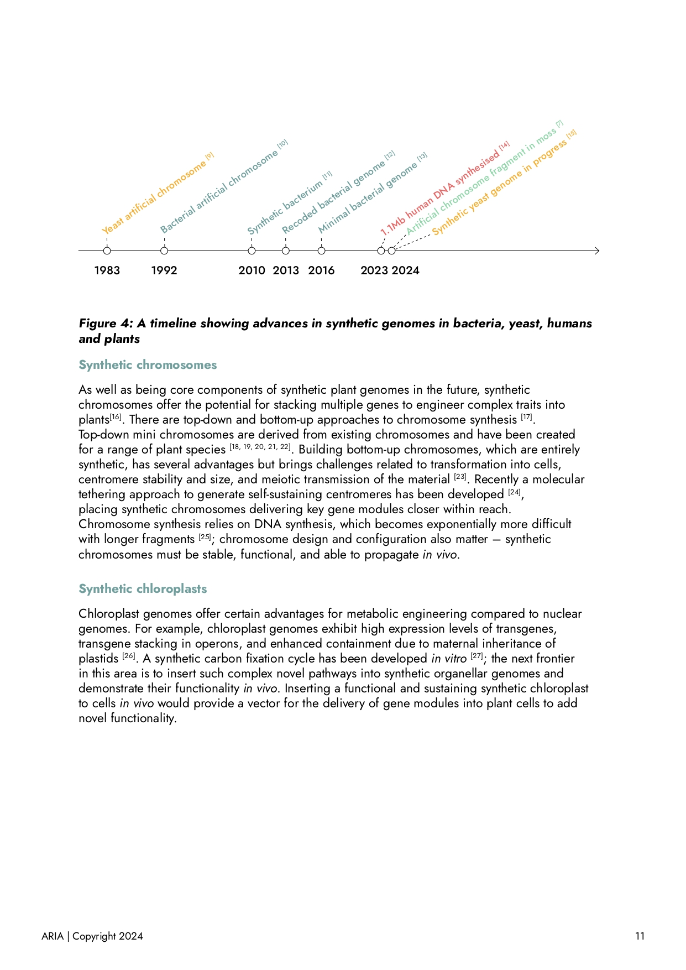

**Figure 4: A timeline showing advances in synthetic genomes in bacteria, yeast, humans and plants.**

*The events recorded are as follows:*

*Bacteria:*

* *1992: Bacterial artificial chromosome* [9]
* *2010: Synthetic bacterium* [10]
* *2013: Recoded bacterial genome* [11]
* *2016: Minimal bacterial genome* [12]

*Yeast:*

* *1983: Artificial chromosome* [13]
* *2024: Synthetic genome in progress* [14]

*Plants:*

* *2024: Artificial chromosome fragment in moss* [7]

*Mammals:*

* *2023: 1.1Mb human DNA synthesised* [15]

Synthetic chromosomes

As well as being core components of synthetic plant genomes in the future, synthetic chromosomes offer the potential for stacking multiple genes to engineer complex traits into plants[1]. There are top-down and bottom-up approaches to chromosome synthesis [17]. Top-down mini chromosomes are derived from existing chromosomes and have been created for a range of plant species [18, 19, 20, 21, 22]. Building bottom-up chromosomes, which are entirely synthetic, has several advantages but brings challenges related to transformation into cells, centromere stability and size, and meiotic transmission of the material [23]. Recently a molecular tethering approach to generate self-sustaining centromeres has been developed [24], placing synthetic chromosomes delivering key gene modules closer within reach. Chromosome synthesis relies on DNA synthesis, which becomes exponentially more difficult with longer fragments [25]; chromosome design and configuration also matter - synthetic chromosomes must be stable, functional, and able to propagate *in vivo.*

Synthetic chloroplasts

Chloroplast genomes offer certain advantages for metabolic engineering compared to nuclear genomes. For example, chloroplast genomes exhibit high expression levels of transgenes, transgene stacking in operons, and enhanced containment due to maternal inheritance of plastids [26]. A synthetic carbon fixation cycle has been developed *in vitro* [27]; the next frontier in this area is to insert such complex novel pathways into synthetic organellar genomes and demonstrate their functionality *in vivo.* Inserting a functional and sustaining synthetic chloroplast to cells *in vivo* would provide a vector for the delivery of gene modules into plant cells to add novel functionality.

# **APPENDIX II: WHY PLANTS?**

*Included to highlight the rationale for plants as the focus of this programme.*

Plants maintain nutrition, survival and reproduction whilst faced with varied environmental conditions; they are therefore highly metabolically complex, producing a wealth of compounds ensuring their survival. Plants have broad impacts on civilisation, ranging from planetary to human health, and are ripe with possibilities: for improving our food systems, mitigating climate change, extracting metals, remediating toxic environments, creating pharmaceuticals and petrochemicals, and developing living buildings. The technological advances which this programme aims to generate would deliver benefits that are highly transferable across these applications. We need food security in a changing climate [28]. Developing plant synthetic genomes - including synthetic genetic units such as chromosomes and chloroplasts - is a key way in which synthetic biology can transform agriculture, at a critical moment of low genetic gains in our major crops and an unpredictably changing climate.

Plant engineering has wide-ranging implications in a range of areas, including sustainable agriculture [29]. Whilst traditional genetic modification approaches and newer CRISPR-mediated gene editing techniques have been used to improve our crops, they are limited in the scope of what they can deliver to plants, both in terms of the number of modifications and edits that can readily be made, and in terms of the range of species which can be worked on due to bottlenecks in plant transformation protocols which are highly species- (and even variety-) specific. Multi-gene delivery and species-agnostic transformation protocols would bring about large step-changes in what can be achieved in plant improvement, necessary to achieve many of the benefits outlined in Table 1, which are largely polygenic traits.

# **SOURCES**

[1] **H. Goold, P. Wright, and D. Hailstones,** “Emerging Opportunities for Synthetic Biology in Agriculture,” *Genes*, vol. 9, no. 7, p. 341, Jul. 2018, doi: [https://doi.org/10.3390/genes9070341.](https://doi.org/10.3390/genes9070341)

[2] “Agriculture - Worldwide | Statista Market Forecast,” *Statista*. <http://www.statista.com/outlook/io/agriculture/worldwide> (accessed Jun. 05, 2024).

[3] **X. Xu *et al.*,** “Trimming the genomic fat: minimising and re-functionalising genomes using synthetic biology,” *Nature Communications*, vol. 14, no. 1, p. 1984, Apr. 2023, doi: [https://doi.org/10.1038/s41467-023-37748-7.](https://doi.org/10.1038/s41467-023-37748-7)

[4] **H. Puchta and A. Houben,** “Plant chromosome engineering – past, present and future,” *New phytologist*, vol. 241, no. 2, pp. 541–552, Nov. 2023, doi: [https://doi.org/10.1111/nph.19414.](https://doi.org/10.1111/nph.19414)

[5] **T. J. Erb**, “Photosynthesis 2.0: Realizing New-to-Nature CO2-Fixation to Overcome the Limits of Natural Metabolism,” *Cold Spring Harbor perspectives in biology*, vol. 16, no. 2, pp. a041669–a041669, Oct. 2023, doi: [https://doi.org/10.1101/cshperspect.a041669.](https://doi.org/10.1101/cshperspect.a041669)

[6] **J. F. Zürcher *et al.***, “Refactored genetic codes enable bidirectional genetic isolation,” *Science (New York, N.Y.)*, vol. 378, no. 6619, pp. 516–523, Nov. 2022, doi: [https://doi.org/10.1126/science.add8943.](https://doi.org/10.1126/science.add8943)

[7] **L.-G. Chen *et al.***, “A designer synthetic chromosome fragment functions in moss,” *Nature Plants*, vol. 10, no. 2, pp. 228–239, Jan. 2024, doi: [https://doi.org/10.1038/s41477-023-01595-7.](https://doi.org/10.1038/s41477-023-01595-7)

[8] **Y. Jiao and Y. Wang**, “Towards Plant Synthetic Genomics,” *Biodesign Research/Biodesign research*, vol. 5, Jan. 2023, doi: [https://doi.org/10.34133/bdr.0020.](https://doi.org/10.34133/bdr.0020)

[9] **A. W. Murray and J. W. Szostak**, “Construction of artificial chromosomes in yeast,” *Nature*, vol. 305, no. 5931, pp. 189–193, Sep. 1983, doi: [https://doi.org/10.1038/305189a0.](https://doi.org/10.1038/305189a0)

[10] **H. Shizuya *et al*.**, “Cloning and stable maintenance of 300-kilobase-pair fragments of human DNA in Escherichia coli using an F-factor-based vector.,” Proceedings of the National Academy of Sciences, vol. 89, no. 18, pp. 8794–8797, Sep. 1992, doi: [https://doi.org/10.1073/pnas.89.18.8794.](https://doi.org/10.1073/pnas.89.18.8794)

[11] **D. G. Gibson *et al.***, “Creation of a Bacterial Cell Controlled by a Chemically Synthesized Genome,” *Science*, vol. 329, no. 5987, pp. 52–56, May 2010, doi: [https://doi.org/10.1126/science.1190719.](https://doi.org/10.1126/science.1190719)

[12] **M. J. Lajoie *et al.***, “Genomically Recoded Organisms Expand Biological Functions,” *Science*, vol. 342, no. 6156, pp. 357–360, Oct. 2013, doi: [https://doi.org/10.1126/science.1241459.](https://doi.org/10.1126/science.1241459)

[13] **C. A. Hutchison *et al.***, “Design and synthesis of a minimal bacterial genome,” *Science*, vol. 351, no. 6280, pp. aad6253–aad6253, Mar. 2016, doi: [https://doi.org/10.1126/science.aad6253.](https://doi.org/10.1126/science.aad6253)

[14] **J. F. Zürcher *et al.***, “Continuous synthesis of E. coli genome sections and Mb-scale human DNA assembly,” *Nature*, vol. 619, no. 7970, pp. 555–562, Jul. 2023, doi: [https://doi.org/10.1038/s41586-023-06268-1.](https://doi.org/10.1038/s41586-023-06268-1)

[15] **D. Schindler, Roy S.K. Walker, and Y. Cai**, “Methodological advances enabled by the construction of a synthetic yeast genome,” *Cell reports. Methods*, vol. 4, no. 4, pp. 100761–100761, Apr. 2024, doi: <https://pubmed.ncbi.nlm.nih.gov/38653205>.

[16] **C. Xu and J. A. Birchler**, “Editorial: Plant artificial chromosomes: progress and perspectives,” *Frontiers in plant science*, vol. 14, Sep. 2023, doi: [https://doi.org/10.3389/fpls.2023.1290386.](https://doi.org/10.3389/fpls.2023.1290386)

[17] **R. K. Dawe**, “Charting the path to fully synthetic plant chromosomes,” *Experimental Cell Research*, vol. 390, no. 1, p. 111951, May 2020, doi: [https://doi.org/10.1016/j.yexcr.2020.111951.](https://doi.org/10.1016/j.yexcr.2020.111951)

[18] **W. Yu, F. Han, Z. Gao, J. M. Vega, and J. A. Birchler**, “Construction and behavior of engineered minichromosomes in maize,” *Proceedings of the National Academy of Sciences*, vol. 104, no. 21, pp. 8924–8929, May 2007, doi: [https://doi.org/10.1073/pnas.0700932104.](https://doi.org/10.1073/pnas.0700932104)

[19] **Eszter Kapusi *et al.***, “Telomere-mediated truncation of barley chromosomes,” *Chromosoma*, vol. 121, no. 2, pp. 181–190, Nov. 2011, doi: [https://doi.org/10.1007/s00412-011-0351-8.](https://doi.org/10.1007/s00412-011-0351-8)

[20] **C. Xu and W. Yu**, “Artificial Chromosomes in Rice *(Oryza sativa),*” *Current protocols in plant biology*, vol. 1, no. 1, pp. 107–120, May 2016, doi: [https://doi.org/10.1002/cppb.20008.](https://doi.org/10.1002/cppb.20008)

[21] **J. Yuan *et al.***, “Site-specific transfer of chromosomal segments and genes in wheat engineered chromosomes,” *Journal of Genetics and Genomics*, vol. 44, no. 11, pp. 531–539, Nov. 2017, doi: [https://doi.org/10.1016/j.jgg.2017.08.005.](https://doi.org/10.1016/j.jgg.2017.08.005)

[22] **M. Kan, T. Huang, and P. Zhao,** “Artificial chromosome technology and its potential application in plants,” *Frontiers in Plant Science*, vol. 13, Sep. 2022, doi: [https://doi.org/10.3389/fpls.2022.970943.](https://doi.org/10.3389/fpls.2022.970943)

[23]. **A. Birchler, N. D. Graham, N. C. Swyers, J. P. Cody, and M. E. McCaw**, “Plant minichromosomes,” Current Opinion in Biotechnology, vol. 37, pp. 135–142, Feb. 2016, doi: <https://pubmed.ncbi.nlm.nih.gov/26723011>.

[24] **R. K. Dawe *et al.***, “Synthetic maize centromeres transmit chromosomes across generations,” *Nature Plants*, vol. 9, no. 3, pp. 433–441, Mar. 2023, doi: [https://doi.org/10.1038/s41477-023-01370-8.](https://doi.org/10.1038/s41477-023-01370-8)

[25] **M. Eisenstein**, “How to build a genome,” *Nature*, vol. 578, no. 7796, pp. 633–635, Feb. 2020, doi: [https://doi.org/10.1038/d41586-020-00511-9.](https://doi.org/10.1038/d41586-020-00511-9)

[26] **R. Bock**, “Engineering Plastid Genomes: Methods, Tools, and Applications in Basic Research and Biotechnology,” *Annual Review of Plant Biology*, vol. 66, no. 1, pp. 211–241, Apr. 2015, doi: [https://doi.org/10.1146/annurev-arplant-050213-040212.](https://doi.org/10.1146/annurev-arplant-050213-040212)

[27] **T. Schwander, L. Schada von Borzyskowski, S. Burgener, N. S. Cortina, and T. J. Erb**, “A synthetic pathway for the fixation of carbon dioxide in vitro,” *Science*, vol. 354, no. 6314, pp. 900–904, Nov. 2016, doi: [https://doi.org/10.1126/science.aah5237.](https://doi.org/10.1126/science.aah5237)

[28] **FAO**, *The State of Food Security and Nutrition in the World 2023*. FAO ; IFAD ; UNICEF ; WFP ; WHO ;, 2023. Available: <https://openknowledge.fao.org/handle/20.500.14283/cc3017en>

[29] **N. J. Patron and S. J. Burgess**, “Editorial Overview: Engineering plants and plant products for a green bioeconomy,” *Current opinion in plant biology*, vol. 71, pp. 102346–102346, Feb. 2023, doi: [https://doi.org/10.1016/j.pbi.2023.102346.](https://doi.org/10.1016/j.pbi.2023.102346)