

Towards an early warning system for climate tipping points

**Programme Thesis**

V2.0

**Gemma Bale + Sarah Bohndiek, Programme Directors**

# **CONTEXT**

This document presents the core thesis underpinning a programme that has now launched.

Sign up [**here**](https://www.aria.org.uk/opportunity-space-updates/) to receive all updates about this opportunity space and see the programme [**here**](https://www.aria.org.uk/forecasting-tipping-points/).

An ARIA programme seeks to unlock a scientific or technical capability that

* changes the perception of what’s possible or valuable
* has the potential to catalyse massive social and economic returns
* is unlikely to be achieved without ARIA’s intervention.

# **UPDATE: OUR THINKING, EVOLVED**

*A summary capturing the evolution of our thinking since publication.*

Since publishing v1.0 of this thesis in May 2024 feedback from experts has challenged and refined its ideas. The following key learnings have emerged from that process so far and have been incorporated into the programme:

* Excellent suggestions in response to the initial set of variables presented in Table 1 were received. The table has now been updated to explicitly include atmospheric variables of importance for the tipping systems of interest (see p. 10), emphasising our holistic approach to the Earth system and the deep connectivity between different climate processes. It is important to emphasise that Table 1 is not exhaustive and we are open to receiving applications that target processes and variables beyond those detailed in the current table.
* A range of platform-specific challenges have emerged, from communications bandwidth to physical robustness, so now highlight some of these challenges in TA2 to demonstrate our interest in funding research that could tackle them (in TA2 on p. 11).
* Feedback suggested expanding the focus from the Greenland Ice Sheet and Subpolar Gyre to include the broader Atlantic Meridional Overturning Circulation (AMOC) as well as Antarctica. These are important tipping systems but to avoid diluting programmatic activities, the original focus is retained. Nonetheless, we are open to receiving proposals from teams who wish to interface with the ARIA programme and are able to leverage other infrastructure or funding opportunities to deploy additional measurements or modelling efforts that encompass the AMOC or Antarctic tipping points.
* Engagement with the economics and social sciences communities has highlighted the need to understand future societal and economic changes we expect to come from the programme. A portion of TA3 funding has now been ring fenced to support studies that interrogate the techno-economic and societal questions of deploying an early warning system weighed against the potential socio-economic impacts of approaching and crossing a particular tipping point. (Reflected in TA3 on p. 12).
* The success of this programme will require sustained, equitable engagement. Therefore the activity previously referred to as ‘Breaking systemic barriers’ has been expanded to become a Cross Cutting Theme (CCT2). CCT2 will focus on: optimising the research environment; improving equity, diversity and inclusion in climate science; and enabling improved climate advocacy to external stakeholders, from policy makers to the general public. (Reflected in CCT2 on p. 14).

# **PROGRAMME THESIS, SIMPLY STATED**

*An overview of the programme thesis, accessible & simply stated*

*This programme thesis is derived from the ARIA opportunity space:* [*Scoping Our Planet: A new lens on climate science*](https://www.aria.org.uk/wp-content/uploads/2024/01/ARIA-scoping-our-planet-v1.pdf)*.*

Climate tipping points exist where changes in a part of the climate system become self-perpetuating. Crossing climate tipping points will lead to substantial and widespread impacts on the Earth and its inhabitants, from unprecedented sea level rise on human timescales, to inhospitable weather extremes. Already, at today’s 1.2°C global warming relative to pre-industrial levels, the threat of crossing climate tipping points in this century is real and urgent, yet we are unprepared for the potentially devastating consequences.

This programme will: innovate and deploy calibrated observations, validate critical processes in models, and unite these to create an early warning system for climate tipping points. We will demonstrate a compelling proof-of-concept that such an early warning system can be *affordable*, *sustainable* and *justified*, despite the low-likelihood nature of these events. The programme will achieve this demonstration through the targeted deployment of low-cost sensing systems in harsh environments, making new observations with well-characterised uncertainties, in tandem with accelerated development of physics- and AI-driven models that can identify the subtle early warning signs of tipping.

If successful, this programme will increase confidence and precisionin *when*tipping points are likely to be crossed, what the *consequences* would be and *over what timescales* they would unfold, establishing early warning signals that are trustworthy and actionable, empowering decision makers to accelerate proactive climate mitigation and adaptation.

# **PROGRAMME THESIS, EXPLAINED**

*A detailed description of the programme thesis, presented for constructive feedback.*

# **Why this programme**

There is no doubt about it: our climate is changing. 2023 broke records for surface temperatures, greenhouse gas levels, ocean heat, sea level rise, Antarctic sea ice extent and glacier retreat [(1)](https://sciwheel.com/work/citation?ids=16365333&pre=&suf=&sa=0). Climate extremes are already causing disruptions for millions of people around the world and inflicting billions of pounds of economic damage [(2)](https://sciwheel.com/work/citation?ids=16409203&pre=&suf=&sa=0). Yet these impacts pale in comparison to the long-term changes we could see if we cross climate tipping points [(3–5)](https://sciwheel.com/work/citation?ids=13585941,493052,16365701&pre=&pre=&pre=&suf=&suf=&suf=&sa=0,0,0).

Major parts of the Earth system are at risk of crossing tipping points within this century, which could put humanity on a catastrophic path. Melting of the Greenland and West Antarctic Ice Sheets would lead to unprecedented sea level rise [(6,7)](https://sciwheel.com/work/citation?ids=14898973,12598537&pre=&pre=&suf=&suf=&sa=0,0). The die-off of warm-water coral reefs could have devastating consequences for biodiversity [(8)](https://sciwheel.com/work/citation?ids=860537&pre=&suf=&sa=0), coastal productivity, and food security [(9)](https://sciwheel.com/work/citation?ids=16369699&pre=&suf=&sa=0). Weakening of the Atlantic thermohaline circulation could shift the atmospheric jet stream, causing regional cooling in Europe and North America with substantial impacts on agriculture [(10)](https://sciwheel.com/work/citation?ids=4649683&pre=&suf=&sa=0). Both thawing of permafrost soils [(11)](https://sciwheel.com/work/citation?ids=6887970&pre=&suf=&sa=0) and warming of the oceans [(12)](https://sciwheel.com/work/citation?ids=16437956&pre=&suf=&sa=0) could add significantly to global warming by reducing their capacity for greenhouse gas storage.

Despite these potentially devastating consequences, we are poorly equipped to characterise the long-term trends of these climate systems or predict their future risk of self-perpetuating change. The timescales over which cascading impacts could unfold are uncertain, ranging from decades to millennia. But if they were to unfold in the next hundred years, the societal consequences would be severe, with an estimated half a billion people exposed to annual coastal flooding events and large losses of crop productivity impacting global food security [(13)](https://sciwheel.com/work/citation?ids=5145384&pre=&suf=&sa=0). The economic damages from Amazon dieback alone could be on par with the gross domestic product of the UK [(14)](https://sciwheel.com/work/citation?ids=11946793&pre=&suf=&sa=0).

The COVID-19 pandemic demonstrated that even with our significant experience of handling infectious diseases, a high-impact low-likelihood event can still have devastating and unequal societal and economic consequences. Humanity has no lived experience of high-impact low-likelihood climate events and even our best projections of their impacts are likely underestimates. It is therefore vital that we deepen our understanding of tipping systems to reduce uncertainty on their likelihood and maximise the time we have to prepare for their impacts. Advances in artificial intelligence (AI) are poised to make significant improvements to our ability to detect the dynamics and timescales of tipping systems, but without coupled improvements in observations, it will prove challenging to convert data into actionable knowledge.

# **Challenges in creating an early warning system**

Generalised mathematical methods have been proposed for theoretical early warning signals of tipping in dynamic climate systems. For example, so-called critical slowing down [(15,16)](https://sciwheel.com/work/citation?ids=16369734,6462270&pre=&pre=&suf=&suf=&sa=0,0) occurs when a tipping system shows weaker recovery from perturbations (i.e. larger responses, with longer duration). Critical slowing down can be detected by careful analysis of the temporal and/or spatial dynamics of the system, conventionally with statistical methods [(17)](https://sciwheel.com/work/citation?ids=16366609&pre=&suf=&sa=0) and more recently with deep learning [(18,19)](https://sciwheel.com/work/citation?ids=11890515,16369928&pre=&pre=&suf=&suf=&sa=0,0). Signs of critical slowing down may already have been detected in several climate systems [(20–22)](https://sciwheel.com/work/citation?ids=16365613,14291279,16033328&pre=&pre=&pre=&suf=&suf=&suf=&sa=0,0,0), although there is disagreement between models [(23,24)](https://sciwheel.com/work/citation?ids=16438011,16438004&pre=&pre=&suf=&suf=&sa=0,0), and increasingly discord between models and measurements [(25)](https://sciwheel.com/work/citation?ids=16438029&pre=&suf=&sa=0), leading to ongoing debate [(6,17,26)](https://sciwheel.com/work/citation?ids=14898973,16436001,16366609&pre=&pre=&pre=&suf=&suf=&suf=&sa=0,0,0). Fuelling this debate are two major challenges, which hinder the conversion of statistical early warnings into trustworthy information that enables climate action:

Firstly, observational challenges arise from the:

* Short-term nature of many climate records,
* Presence of discontinuities in time-series,
* limited spatial and/or temporal resolution of many measurements,
* poor capture of key processes in climate system feedbacks,
* residual uncertainty in the observations (both instrumental and methodological) compared to the size of any ‘signal’.

These factors make the confident identification of subtle changes in our current datasets challenging [(20,27,28)](https://sciwheel.com/work/citation?ids=16365613,16365714,16366454&pre=&pre=&pre=&suf=&suf=&suf=&sa=0,0,0). Furthermore, some of the climate systems most at risk of tipping are chronically under-observed [(7,29)](https://sciwheel.com/work/citation?ids=11563296,12598537&pre=&pre=&suf=&suf=&sa=0,0) because they require instruments to survive in hostile environments (e.g. with extreme pressure or freezing temperatures) and/or demand depth-resolved data that is beyond the reach of satellites. The oceans and cryosphere are particularly challenging [(30)](https://sciwheel.com/work/citation?ids=16409244&pre=&suf=&sa=0), hampered by technological and logistical challenges [(31)](https://sciwheel.com/work/citation?ids=16438054&pre=&suf=&sa=0); existing observational networks are extremely valuable [(32–35)](https://sciwheel.com/work/citation?ids=4301644,16438035,11811077,16438062&pre=&pre=&pre=&pre=&suf=&suf=&suf=&suf=&sa=0,0,0,0) but relatively sparse, leaving unmet needs ranging from interrogating the dynamics of ice sheet grounding lines to resolving the deep currents of the ocean.

Secondly, modelling challenges arise because:

* Modelling of high-impact low-likelihood events such as tipping points, associated feedback processes, and their cascading interactions [(36,37)](https://sciwheel.com/work/citation?ids=14487250,6868182&pre=&pre=&suf=&suf=&sa=0,0) remains in its infancy and needs a catalytic investment to deliver the capabilities that we need for early warning.
* Our best climate models are computationally expensive and still do not include all the basic Earth system processes [(24)](https://sciwheel.com/work/citation?ids=16438004&pre=&suf=&sa=0) let alone the potential tipping processes [(38)](https://sciwheel.com/work/citation?ids=16369841&pre=&suf=&sa=0), limiting our confidence in predicting *when* a system will tip, what the *consequences* will look like, and *over what* *timescales* theywill unfold.
* Modelling and measurement products are often obtained at different spatial and temporal scales. It is therefore hard to combine models with measurements to achieve meaningful validation, or conversely, to guide optimal targeting of measurement variables or locations for early warning from model outputs [(20,29)](https://sciwheel.com/work/citation?ids=11563296,16365613&pre=&pre=&suf=&suf=&sa=0,0).

# **Our approach**

This programme will tackle both observational and modelling challenges holistically to create an early warning system for climate tipping points, rapidly providing a compelling proof-of-concept that such a system can be *affordable*, *sustainable* and *justified*. For an early warning system to be *affordable* and *sustainable*, we must consider financial and environmental impacts of future implementation from the outset.

To economically address the current observational challenges, the programme will capitalise on emerging innovation in low size, weight, power and cost (SWaP-C) instrumentation. Thanks to SWaP-C innovation in electronics and photonics delivering an unprecedented telecommunications and cloud computing infrastructure, we can now put a multi-sensor enabled smartphone in every pocket and smartwatch on every wrist. Taking a SWaP-C ‘internet of things’ approach to climate monitoring tackles two coverage issues: the creation of new sensing systems to take data in physical locations that are currently out of reach, and the dramatic upscaling of established measurements to increase density of sampling.

To address modelling challenges, the programme will capitalise on the phenomenal pace of innovation in AI. AI is already having a huge impact on weather forecasting [(39)](https://sciwheel.com/work/citation?ids=16413972&pre=&suf=&sa=0) but has barely been explored in climate tipping points. The programme will harness the power of AI to: overcome data quality limitations such as discontinuities, resolution or sensitivity loss from low SWaP-C sensing; enable the conception of fundamentally new ways to detect tipping trends; target the variables and locations for future measurement systems; and reduce the computational cost of attaining an early warning.

For an early warning system to be *justified*, it must be actionable and trustworthy; we can afford neither false positives nor false negatives. Building trust requires detailed cross-validation between physical models and observations, however, in the challenging ice sheet and ocean environments, the current observational data is insufficient. Furthermore, there are increasing examples of discordance between models and measurement as climate change becomes more extreme [(40,41)](https://sciwheel.com/work/citation?ids=16413981,16413980&pre=&pre=&suf=&suf=&sa=0,0), demanding improved observational efforts to constrain models and reduce uncertainty [(23)](https://sciwheel.com/work/citation?ids=16438011&pre=&suf=&sa=0). To tackle this, the programme will rapidly develop and deploy coordinated affordable instruments to better parameterise the GrIS and SPG, capturing system feedbacks through a scalable, harmonised deployment at high spatial and temporal density, across a range of platforms, from deep sea gliders to airborne and spaceborne sensors. Calibration and validation for uncertainty and bias quantification will be embedded across the programme to create a real-world demonstration that provides sufficiently high quality data and modelling to deliver an early warning.

A holistic approach uniting measurements and models is vital to the successful creation of an early warning system, which depends on breaking of silos across multiple axes (e.g. climate / tech, between Earth system domains, measurement / models) and can only be addressed through a programmatic funding approach.

# **What we will achieve**

Programme innovations will focus on the tipping systems of the Greenland Ice Sheet (GrIS) and the adjacent Subpolar Gyre (SPG) circulation (Figure 1) to demonstrate the core concepts needed to deliver the early warning system. These are prioritised as ‘at risk’ systems with different tipping dynamics, placing different demands on modelling and observation. GrIS and SPG are also intimately connected, since freshwater melt from the ice sheet changes the oceanic circulation while ocean warming influences melt rates, and are chronically under-observed. Furthermore, they are governed by interactions between multiple Earth system domains, with interesting interfaces at the ice / ocean / atmosphere / land boundaries. Using this pair of systems (which benefit from geographic proximity to the UK for logistics) will help to evaluate generalisability of methods to other tipping systems.

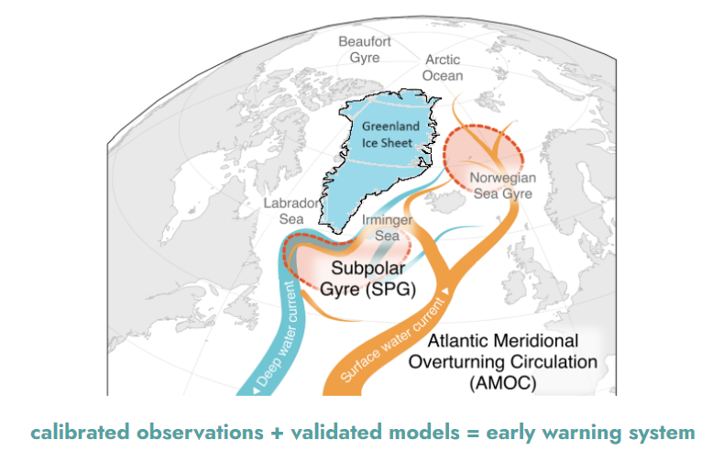

***Figure 1:*** *The image shows the tipping points targeted for demonstration of an early warning system: Greenland Ice Sheet (GrIS) and the North Atlantic Subpolar Gyre (SPG) Circulation.**The SPG links into the Atlantic Meridional Overturning Circulation (AMOC), also shown, but the latter will not be an immediate target of this programme. Adapted from Global Tipping Points report p.128.*

If successful, this programme will increase our confidence and precision for *when* tipping will occur in the GrIS and SPG, what the *consequences* of crossing these tipping points will be, and *over what timescales* impacts will be felt. The programme will demonstrate an ‘internet of things’ for climate monitoring, to build an early warning system through united innovation in observation and modelling. Improving confidence [(42)](https://sciwheel.com/work/citation?ids=16413970&pre=&suf=&sa=0) in both the timescales and expected impacts of tipping will empower decision making around adaptation for tipping points, while adding urgency to mitigation activities towards net zero. Greater confidence in tipping phenomena will more broadly change the adaptation conversation to include planning for high-impact low-likelihood events, for example, sustained global implementation of early warning systems for these and other tipping points, or more regionally, active planning of suitable flood defences [(43)](https://sciwheel.com/work/citation?ids=16413881&pre=&suf=&sa=0) and measures to ensure long-term energy and food security in a changing climate.

By ensuring that the methods we deploy (both instrumental and computational) are low-cost (or have the potential to be), the programme demonstration can in future be expanded to provide an *affordable* and *sustainable* automated system that is *justified* because it gives a trustworthy timely estimate of the risks, timescales and potential impacts of the tipping points. The methods developed in GrIS and SPG can also be extended to other tipping systems, such as the West Antarctic Ice Sheet or the Atlantic meridional overturning circulation (AMOC), which have similar physical dynamics to those included in this programme, and also to non-oceanic or cryosphere tipping points, such as in the Amazon rainforest, by building on the generic methods created.

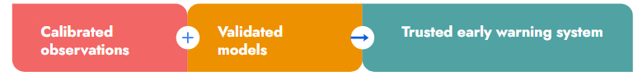

**Equation 1 caption:** The image shows that the addition of calibrated observations and validated models will lead to a trusted early warning system.

Demonstrating the value of rapid, coordinated, low-cost observations directly integrated with models will have wider impacts in the field of Earth observation, which could further improve weather forecasting and climate projections. More broadly, we expect the demands of our programme to catalyse innovation in adjacent fields, such as electronics, photonics, space, and AI.

# **Programme structure**

We plan to fund a five-year coordinated programme uniting a group of R&D Creators, recipients of ARIA research funding, that bring with them a diverse range of expert knowledge and commit the time needed to work closely together to develop a shared language and mutual understanding. The programme will fund teams across a broad range of institutions with an emphasis on breaking systemic silos. The programme will be organised into three deeply connected technical areas and a cross-cutting theme (Figure 2):

* **Technical area 1 (TA1)** will accelerate innovation and development of low-cost sensing systems that address unmet observational needs in the ocean and cryosphere, linked to inferring the health of tipping systems or the direct climate drivers of their tipping behaviour.
* **Technical area 2 (TA2)** will deploy existing and newly developed sensing systems in a coordinated multi-year field campaign targeted to the Greenland Ice Sheet and Subpolar Gyre to create an observational network to monitor these tipping systems.
* **Technical area 3 (TA3)** will unlock the mathematical, physical and computational methods necessary to create and test an early warning system for climate tipping points.

Embedded across the entire programme are two **cross-cutting themes** (CCTs):

* **Cross cutting theme 1 (CCT1)** underpins the integration of measurement and modelling through calibration and validation, to reduce uncertainties and maximise interoperability across models and data. Each applicant team will be required to demonstrate that they have considered these standardisation efforts in their proposal. We expect to partner with the National Physical Laboratory to provide infrastructure and coordination for CCT1.
* **Cross cutting theme 2 (CCT2)** exists to break systemic barriers that impede the creation of long-term climate records that are vital for early warning, limit the flow of diverse talent into this important field, and hinder decision-making through poor communication of climate risk and impacts. Each applicant team will be required to demonstrate how they will take action to overcome these barriers in their proposal.

Our vision for unifying teams across TA1, 2 and 3 is illustrated in a cycle (Figure 2), whereby new observations can feed into modelling experiments and model outputs can be used to target future observations. All of this is supported and strengthened by the CCTs, as CCT1 will ensure smooth interaction between TAs and CCT2 will aid productive dialogue between researchers, decision-makers and the public.

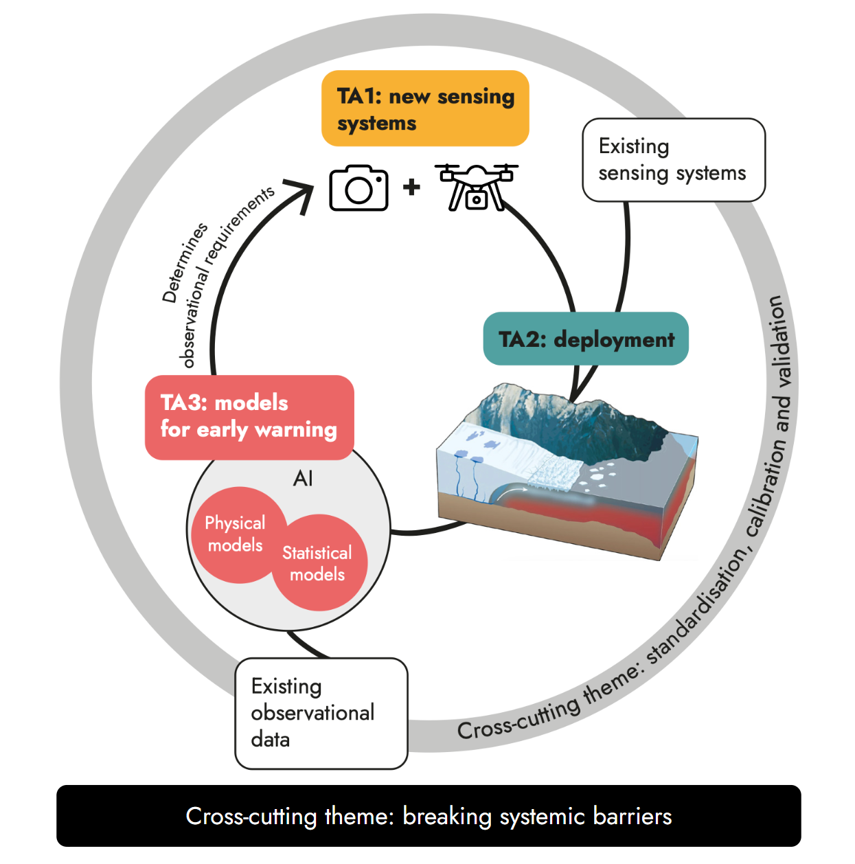

***Figure 2 caption:*** *An illustration of how we expect the TAs and the cross-cutting themes to interact. Existing sensing systems available in the external landscape and new sensing systems developed in TA1 of the programme feed into TA2: deployment. Existing observational data and new observational data obtained from TA2, feed into TA3: models for early warning. TA3 determines observational requirements, and feeds back into TA1: new sensing systems. The circular structure indicates the iterative nature of the research and demonstrates opportunities for external engagement with existing observational networks and datasets. The Cross-cutting themes: breaking systemic barriers and standardisation, calibration and validation are present throughout. TA2 figure from* [*(33)*](https://sciwheel.com/work/citation?ids=16438035&pre=&suf=&sa=0)*.*

## **TA1: Coordinated design and development of affordable climate sensing systems**

Multidisciplinary teams of sensor and platform specialists will work in TA1 to co-design *affordable* and *sustainable* ‘sensing systems’ for a harmonised ‘internet of things’ network of remote and *in situ* observations.

Initially, teams will target observations of processes within the GrIS and SPG that are crucial for understanding instabilities in these systems but not well served by existing measurements, particularly remote sensing. Some of these processes can be linked to essential climate variables (ECVs) drawn from the Global Climate Observing System, which already have target performance requirements [(44)](https://sciwheel.com/work/citation?ids=16369943&pre=&suf=&sa=0), defined by the WIGOS 2040 report [(45)](https://sciwheel.com/work/citation?ids=16369957&pre=&suf=&sa=0). Initial variables have been suggested here for community engagement and feedback (Table 1). As the programme evolves, all teams will be involved in a process of defining additional variables and requirements, along with target measurement locations, as informed by the modelling outcomes of TA3. We plan to open a second solicitation (Figure 3) to fund innovation in new priority variables.

We expect Creator teams to outline ambitious design specifications for their sensing system to resolve the target variable(s) of interest and perform an environmental assessment to consider the climate impact of the system. As target specifications will be judged compared to the state-of-the-art based on their improvements in performance or lower SWaP-C, we define an improvement ratio, *IR*:

*IR*

**Equation 2 caption:** An illustration of the equation used to determine the improvement ratio, *IR*. *IR* can be calculated by taking the performance of the sensing system, and dividing it by the product of the size, weight, power and cost.

where *performance* could include (but not be limited to) any combination of the following:

* Precision
* Accuracy
* Spatial resolution
* Temporal resolution
* Sensitivity
* Longevity
* Coverage.

Successful teams in TA1 who demonstrate that they can measure a target variable at a >100x increase in *IR* (with at least 10x of that improvement from potential cost savings) with a robust sensing system will be given the opportunity to demonstrate their sensing systems against benchmarking activities defined by CCT1 and with early stage field testing, which will be applied to stage-gate transition into field deployment in TA2 at different entry points throughout the programme.

***Table 1:*** *Priority processes under consideration for targeting of initial measurements. The list is not exhaustive and Creators may target variables beyond this list, provided they explain why the target variable is important for understanding tipping-related processes in GrIS and the SPG. Note that some target measurements are important for more than one process so appear more than once. Even for a process that can already be measured, further innovation may be needed to achieve it through a SWaP-C instrument or to achieve higher performance.*

| **Earth system domain** | **Process** | **Example target(s) for measurement** | **Can it currently be measured?** |
| --- | --- | --- | --- |
| Cryosphere | Marine ice sheet instability (MISI) | Grounding line location (m) and front location (m)  Grounding line ice thickness (m)  Sea surface salinity (g kg-1)  Depth-resolved interior salinity (g kg-1)  Surface / subsurface melt rates at the ice-ocean interface (ms-1) | No  Yes  Yes  No  No |
| Marine ice cliff instability (MICI) | Ice sheet velocity (ms-1)  Ice cliff geometry (m)  Ice sheet surface melting (ms-1) | Yes  Yes  Yes |
| Surface elevation melt instability (SEMI) | Ice sheet velocity (ms-1)  Ice sheet surface melting (ms-1) | Yes  Yes |
| Sea ice | Sea ice thickness (m)  Sea ice temperature (K) | No  Yes |
| Ocean / Cryosphere | Ocean warming  Fjord circulation (see also ocean / atmosphere variables) | Sea surface temperature (K)  Depth-resolved interior temperature (K)  Mixed layer depth (m)  Surface albedo (dimensionless)  Subglacial / river discharge rate (m3s-1)  Supraglacial runoff rate (m3s-1)  Glacier front melt / calving rate (m yr-1)  Glacier velocity (m yr-1) | Yes  No  Yes  Yes  Yes  Yes  Yes  Yes |
| Ocean | Ocean biogeochemistry | Total alkalinity (µmol kg-1)  Dissolved oxygen concentration (µmol kg-1)  Nutrients (e.g. phosphate, nitrate, silicate, µmol kg-1)  Phytoplankton diversity (#/unit vol)  Phytoplankton biomass (mg m-3)  Phytoplankton productivity (µmol m-2 s-1)  Chlorophyll-a concentration (µg L-1) | Yes  Yes  Yes  No  Yes  No  Yes |
| Ocean / Atmosphere | Ocean circulation | Sea surface salinity (g kg-1)  Depth-resolved interior salinity (g kg-1)  Total surface currents (ms-1)  Ekman currents (ms-1)  Geostrophic current (ms-1)  Vertical mixing (ms-1)  Significant wave height (m)  Ocean surface vector wind speed (ms-1)  Ocean surface stress (Nm-2) | Yes  No  No  Yes  Yes  No  No  Yes  No |
| Ocean surface heat flux | Radiative heat flux (Wm-2)  Sensible heat flux (Wm-2)  Latent heat flux (Wm-2) | Yes  Yes  Yes |
| Atmosphere | Precipitation | Accumulated precipitation (mm) | Yes |
| Atmospheric warming and circulation near surface | Air temperature (K)  Wind speed (ms-1)  Wind direction (degree true)  Wind vector (ms-1)  Atmospheric pressure (hPa) | Yes  Yes  Yes  Yes  Yes |

## **TA2: Rapid deployment of monitoring technologies for an early warning system**

A field campaign will be executed in TA2 to demonstrate that appropriately integrated, calibrated, and validated SWaP-C sensing systems can meet the demands for sustained, high-density high-coverage measurements needed to facilitate early warning in tipping systems. The targeted variables (including locations, resolutions, coverage, etc.) will ultimately be determined by TA3, but will initially focus on the defined processes for TA1 (see Table 1).

We challenge the assumption that deployment of novel technologies for climate monitoring requires highly specialised instrumentation delivered through long-term missions that are slow and costly. By targeting a lower price point for deployment, the cost-benefit analysis for an early warning system can tip in favour of implementation by policymakers. We anticipate that we will fund the development of a diverse range of sensing systems, from a range of teams across academia and industry, including novel remote-sensing sensors, as well as innovative *in situ* platforms, which could contribute to a high density 4D measurement mesh. These could include, but are not limited to:

* Small / cube / nano satellites,
* Drones / airborne systems / high altitude platforms (HAPs),
* Drifters / floats / buoys,
* Submersibles / gliders / sea drones.

We particularly welcome innovations that fill unmet needs in the observing ecosystem, for example:

* At-sea, under-sea and under-ice real-time communications and navigation, enabling fleet operation of autonomous vehicles.
* Full-depth ocean robotic platforms capable of routine sustained observations to abyssal depths.
* Lower cost and lower carbon footprint ice-capable vessels, both uncrewed and autonomous, enabling year-round sustained observations.
* Satellite constellations or high altitude platforms suitable for polar observing, with ultra-high bandwidth communications for full real-time data retrieval and rapid command transmission.

Teams will be given the opportunity to rapidly deploy sensing systems in a comprehensive, massively coordinated field campaign in the GrIS and SPG, to demonstrate new technologies and sow the seeds of a long-term monitoring capability. The programme will benefit from existing satellite and *in situ* measurements in these regions that can provide a baseline for performance comparison (see CCT1) and where appropriate, may also fund expansions of these. We anticipate securing at least one field campaign logistics partner to assist in deployment matters, including regulation, independent qualification, testing, launch, and maintenance. Examples of operations that could be managed by a partner include establishing a long-term camp in Greenland, or taking a low-cost satellite from design to launch. The societal, ethical and environmental implications of the field campaign will be considered responsibly through transparency, public participation and consultation, with impact assessment performed for all systems.

The field campaign will include successful teams from TA1 but will also be open to external bids from teams not previously involved in the ARIA programme. We anticipate funding external bids into TA2 at the second solicitation point (Figure 3) from: a) teams who wish to continue or extend existing climate monitoring records that are vital for parameterising tipping systems but are unsuitable for funding in the current landscape; and b) teams who have developed novel sensing systems through other funding mechanisms or within companies but are unable to fund deployment through other means. Integrating new teams into the field campaigns also affords the opportunity to more rapidly target additional climate variables (e.g. as determined by TA3).

TA2 deployment will begin in year 2, due to the urgency with which we need to start to build these climate records, with initial field testing expected before this date and further deployment windows beyond this date, expected at years 3, 4 and 5. In many innovative systems, field testing is likely to be an iterative process to build better performance. Rapid deployment timeframes will force innovation in the process of testing and certification of technologies, particularly for satellite launches, allowing for learning and iteration of device design. At the end of the programme, our ambition is to deliver a permanent network of low-cost sensing systems for sustained long-term observation of those variables found to be most impactful for an early warning system (Legacy, Figure 3).

## **TA3: Uniting models and measurements to create an early warning system**

Even our best climate models do not yet include all processes and feedbacks involved in high-impact low-likelihood events [(46)](https://sciwheel.com/work/citation?ids=16369911&pre=&suf=&sa=0) and they are computationally expensive. These two factors make it hard to identify the observable variables and statistical distributions that best capture characteristic dynamics of tipping systems or their likely impacts. TA3 will invest in refining physical and statistical modelling methods to identify generic and system-specific early warning indicators from existing models and datasets, as well as coordinating modelling and measurement to prioritise high value observations for a future early warning system.

Teams will be funded to develop, test and cross-validate competing modelling approaches to characterise the tipping dynamics and subsequent impacts of crossing tipping points in the Greenland Ice Sheet and/or Subpolar Gyre. These systems have different timescales of response to forcing and distinct global impacts, providing an opportunity to compare the potential of generic statistical early warning signs, such as critical slowing down, against more direct system-specific indicators, such as changes in system forcing.

We expect research in TA3 to include:

* Creation or application of methods to maximise the information available from existing observations and models, such as reanalysis or digital twins, to address spatial or temporal discontinuities in datasets, or integrate alternative data sources, such as extension of historical records through digitisation, integration of indigenous measurements [(47)](https://sciwheel.com/work/citation?ids=16438070&pre=&suf=&sa=0), or paleo-climate research.
* The development and validation of mathematical approaches for detecting generic and/or system-specific early warning signals from physical model projections and/or assimilated observational data, such as statistical analyses or space-for-time substitution.
* Innovation in the use of data-driven approaches, such as exploiting AI to: detect characteristics of tipping phenomena in raw data, combine observations from disparate sources into unified datasets, or accelerate observing system simulation experiments (OSSEs) that help identify variables or locations to enhance monitoring and target efforts in TA2.
* Advances in physical models, or hybrid approaches combining physical models with AI-based models, for example, training AI-based climate models using data compilations from physical model runs.
* Economic assessment of both the techno-economic impacts of technologies arising from the programme, costs of deploying an early warning system [(48)](https://sciwheel.com/work/citation?ids=16577821&pre=&suf=&sa=0), and the economic impacts of approaching and crossing a particular tipping point considering the anticipated exposures [(49)](https://sciwheel.com/work/citation?ids=11930166&pre=&suf=&sa=0). We expect to interact with [The Productivity Institute](https://www.productivity.ac.uk/) for initial exploration of this topic.
* Other research activities needed to make the EWS actionable (linked to CCT2) such as science and technology studies or other topics in the social sciences.

At the end of the programme, we expect to have demonstrated iterative model validation against field and/or historical data, moving towards a real-time operational platform for long-term measurement of early warning signals, automatically extracted from the observational data (Legacy, Figure 3).

## **Cross-cutting theme 1: Reducing uncertainty and maximising interoperability through standardisation, calibration and validation at scale**

Vital to the unification of modelling and measurement is embedding processes for standardisation, calibration, and validation into the programme at all levels to secure high quality measurement data from TA2 and deliver it for use in an appropriate format for TA3. The programme will seek to maximise harmonisation by partnering with National Physical Laboratory, the UK’s National Metrology Institute. In this way, demands for new reference standards and test methods can be identified early so that they can be assessed and developed in readiness for TA2 implementation. To maximise efficiency, these concepts need to be built-in during the TA1 phase. Achieving a close coordination of models and measurements requires consistent interfaces and infrastructure for open data integration, assimilation and dissemination, such as cloud storage / compute.

Creating standards may require consensus-finding activities. Consensus-finding is expected to be led by programme-funded Creators, but must engage the wider community in the process and we expect to be facilitated by independent experts drawn from the metrology community through our partner organisation.

To deliver appropriate calibration and validation technologies that are suitable for deployment across the range of sensing systems used by the programme, we will fund specific technology innovation in calibration and validation systems as required by projects in the TAs. Funding could also be used to include existing ‘gold-standard’ technologies, which new technologies can be referenced against. We expect to establish a common test centre for benchmarking of sensors and early-stage pre-field testing of novel sensor systems that can provide guidance and support to the TA teams.

## Cross-cutting theme 2: Breaking systemic barriers in climate science

Our discovery process has highlighted systemic barriers that could impede the long-term impact of our programme. Climate change affects everyone, so it is vital that we include people of all backgrounds, across all industries, and at different career stages in our programme. Our approach to funding will consider the context of recruitment and retention in the field to ensure long-term climate monitoring and records. We will actively support co-design and advocacy from the outset. We will support three core initiatives within CCT2:

1. **Optimising the research environment.** There is a skills shortage of mathematicians, computer scientists and technologists contributing to current climate research. We will enable mobility across institutions (e.g. between academia, industry, and national laboratories) or knowledge exchange activities on an international scale; funding can be requested under CCT2 for early career researchers within our programme to use for this purpose. We are also keen to engage and support individuals who have not previously worked in climate science, but are excited to pivot their careers towards the topic, by encouraging a high percentage of “PI time” to be costed, or enabling individuals to undertake secondments to dedicate a significant proportion of their time to the effort.
2. **Improving equity, diversity and inclusion (EDI) in climate science.** At the point of application, we ask our Creators to pro-actively consider how they will improve EDI in their own projects. We will also run a national initiative, the “Future climate innovators programme”, a youth-led competition to improve EDI in Earth and space science. We have been inspired to develop and deliver a youth-led outreach programme, designed to engage the next generation of climate innovators. We’re looking to demonstrate that new mode of citizen science. The initiative will capitalise on the ability of space science to captivate the imagination and the enthusiasm of the next generation to take on climate change.
3. **Enabling climate advocacy** by empowering our Creators to engage in impactful climate communication through research, programme-wide training, and communication content partnerships among our Creators. We encourage Creators to cost for activities that support this ambition within their proposals.
   1. We envisage using the field campaign as an opportunity to engage in co-creation with media and communication experts.
   2. Risk communication is notoriously difficult but vital to future societal impacts. In partnership with experts, we will train our Creators to scientific evidence papers and toolkits that are accessible to policymakers and other external industries to help them understand tipping point risks and consequences.
   3. Trainees in our programme will form a unified interdisciplinary cohort to advocate for deeper collaboration between modelling and measurement. We encourage Creators to consider including PhD students in their projects to build knowledge of climate tipping points in the next-generation.
   4. Our programme Creators will be encouraged to engage in advocacy with the wider research community, for example, through international summer schools and other training opportunities.

# **Goals and scope**

The following tables summarise the overall programme goals and define areas that would be considered out-of-scope. Table 2 gives a summary of the programme goals within the five-year timeframe. Table 3 outlines longer term ambitions that teams should be able to demonstrate a pathway towards.

***Table 2:*** *Goals that are expected to be demonstrated by teams within one or more TAs in the timeframe of the programme.*

| **Must be demonstrated within the programme** | **TA** |
| --- | --- |
| Sensing systems with >100x increase in *IR* (with at least 10x of that improvement from potential cost savings) | 1+CCT |
| Sensing systems robust to harsh environments | 1+2 |
| Coordinated sensing systems deployed rapidly | 1+2 |
| Cross-calibration of multiple systems to maximise data quality | CCT |
| Integration with existing observing networks and missions | 1+2+CCT |
| Enabling of new observations of poorly understood processes | 1 |
| Data suitable (e.g. coverage/resolution) for model validation | all |
| Appropriate representation of physical processes in models | 3 |
| Validation of physical models | 3+CCT |
| Increased speed and capability of tipping point modelling | 3 |
| Deployment of model-driven tipping system observations | all |
| Testing of early warning system indicators | 3 |
| Convergence of model predictions with observational records | 2+3 |
| Reduced uncertainty in timescales of tipping | 3 |
| Improved understanding of societal / economic impacts of tipping | 3 |
| Report on the state of climate tipping points knowledge in 2029 | all |

***Table 3: Ambitions beyond the programme that teams must show a clear pathway to fulfilling.*** *\*confidence as determined by the IPCC process* [*(42)*](https://sciwheel.com/work/citation?ids=16413970&pre=&suf=&sa=0)*.*

| **Must have a pathway to delivery beyond the programme** | **TA** |
| --- | --- |
| Sensing systems with >1000x increase in *IR* | 1 |
| Automated observation and EWS detection | all |
| Scalable and sustainable deployment | 1+2 |
| Sustained observations through a permanent sensing network | 2 |
| Affordable sensing systems and models | all |
| An early warning system with decadal precision | all |
| Increased confidence* in the global risks of tipping | 3 |
| Reduced uncertainties in early warning signals | 3 |
| Methods translatable to other tipping systems | all |

Table 4 gives a breakdown of areas that we expect to be out of scope for this programme, along with the reasoning we have taken in coming to these decisions. [Opportunity seed funding](https://www.aria.org.uk/our-opportunity-seeds/) will be available at different timepoints throughout the programme to support individuals or teams pursuing ambitious research that is out of scope for the programme, but which falls within the scope of the wider [Scoping Our Planet](https://www.aria.org.uk/wp-content/uploads/2024/01/ARIA-scoping-our-planet-v1.pdf) opportunity space.

***Table 4: Work that is out of scope of the programme.***

| **Out of scope** | **Comments** |
| --- | --- |
| Development of technologies that do not contribute to measuring one of the tipping system processes highlighted in Table 1. | May be suitable for programme funding if a strong case is made for why the process is relevant to the tipping system(s). May be suitable for opportunity seed funding. |
| Development of technologies that monitor the Earth system but not for the purpose of providing early warning of the GrIS or SPG tipping points. | Would be suitable for opportunity seed funding. |
| Modelling efforts not related to the focus tipping points specified in the programme. | May be suitable for opportunity seed funding. |
| Monitoring or modelling of climate engineering or climate intervention activities. | This programme is focussed on monitoring and modelling for early warning of tipping points. The ARIA programme [Exploring Options for Actively Cooling the Earth](https://www.aria.org.uk/wp-content/uploads/2024/05/ARIA-Actively-cooling-the-earth-programme.pdf) will focus on intervention activities. |

# **How we expect to fund**

The three TAs will run in parallel over a five-year period with two solicitations - in year 0 and year 2 (Figure 3). Partner organisations will be engaged from the start of the programme.

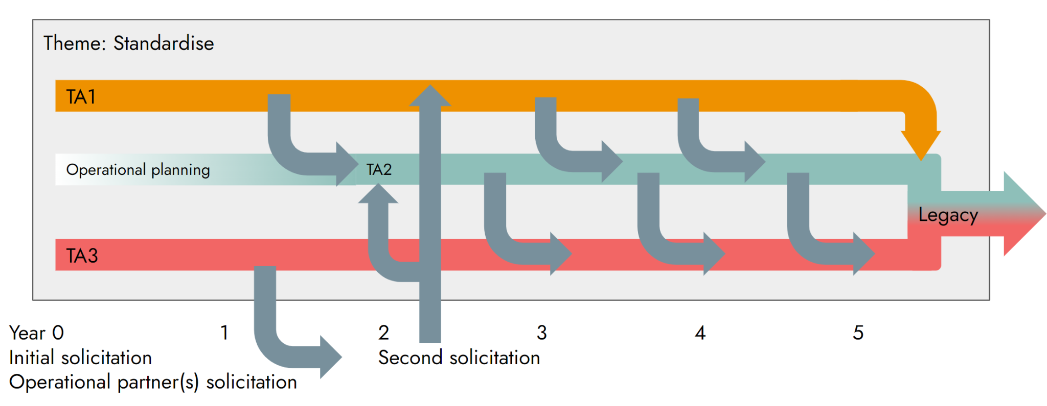***Figure 3:*** *Schematic of expected timelines for interaction of the TAs and timepoints for solicitations.*

Teams will apply to be part of one of the three TAs; those who wish to apply for the CCT would need to do so in partnership with a team in one of the TAs. Of course, some Creators might not have an existing network ready to apply with, so we plan to allow two routes of application into the programme:

* Stream 1 – Proposals formulated by a multidisciplinary team that are submitted by a lead organisation.
* Stream 2 – We will facilitate a process for individuals or teams of domain experts (e.g. technologists, oceanographers) who apply to engage in teaming based on their specific expertise and desired collaborative partnerships.

We will curate teams from both streams to ensure that we have a balanced portfolio of projects. We are aware of the complex and challenging nature of such interdisciplinary work and we need to break silos across multiple axes (e.g. climate / tech, Earth system domains, measurement / models) in order to succeed. Our coordinated programmatic approach should tackle this, but we additionally plan to encourage collisions across the TAs through regular Creator fora, for example: sandpit workshops to enable co-design of sensing systems, and design sprints associated with performance prizes. Aligned with these aspirations, we also expect Creators to dedicate a substantial proportion of their working time to the programme. We will also provide the resources necessary to enable trainees funded through the programme to form a unified interdisciplinary cohort, to achieve deeper collaboration between modelling and measurement in the next-generation.

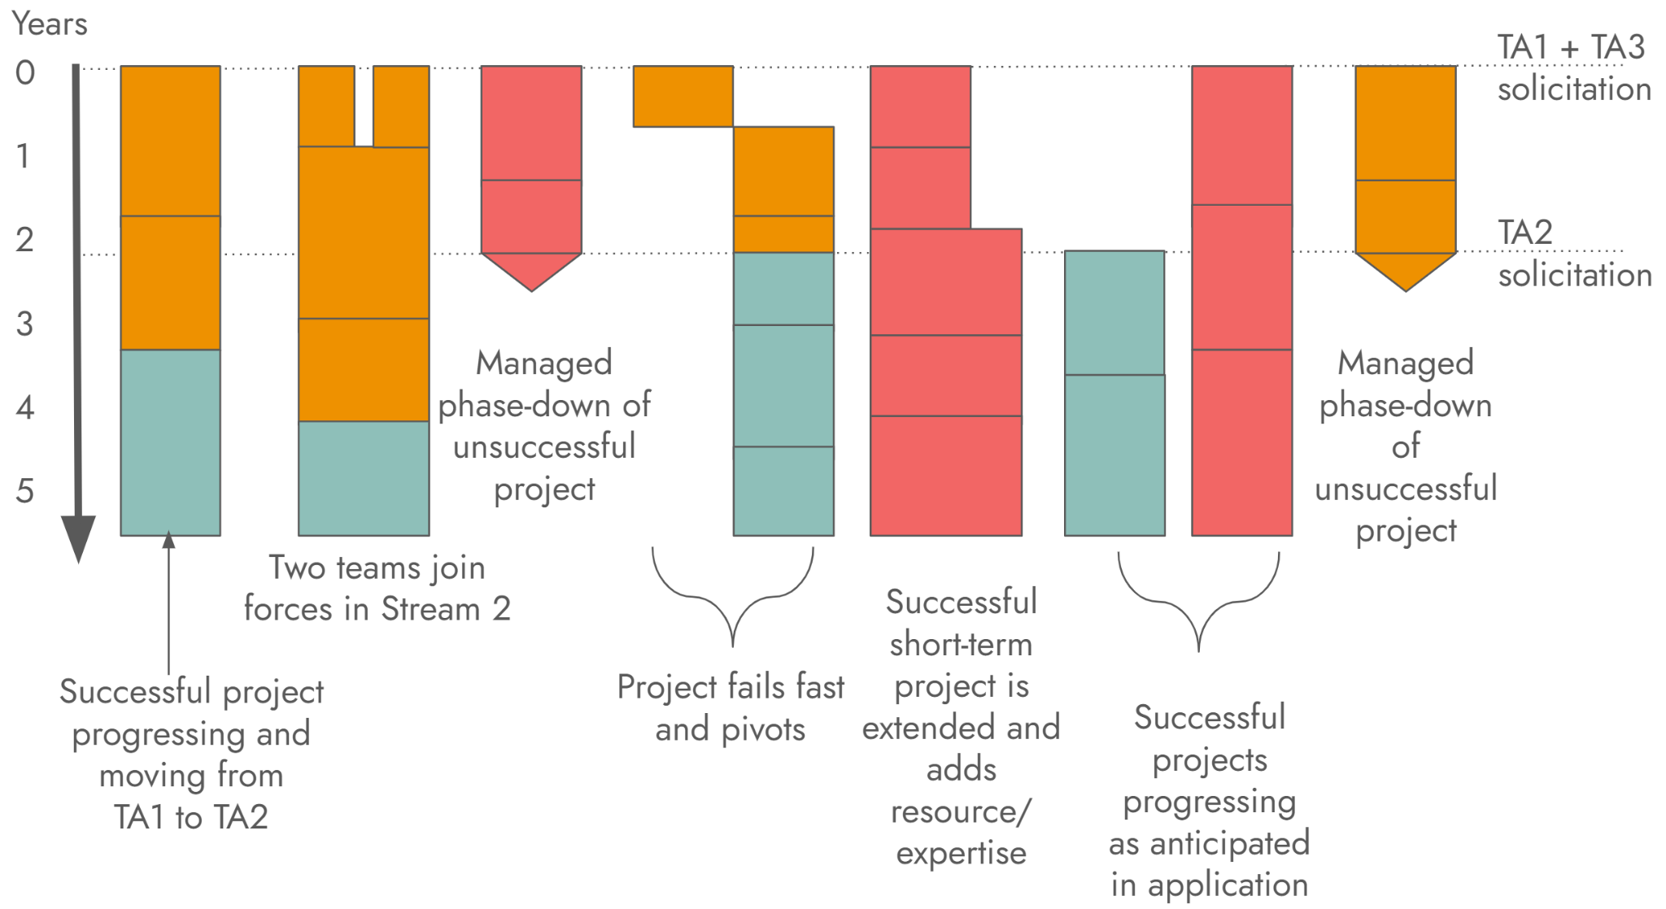

***Figure 4:*** *Illustrative examples of how various projects could evolve across the programme duration. Colours denote TAs: TA1, TA2, TA3.*

**What we are still trying to figure out**

* Variables to target? What other processes should we target? Uncertainties to aim for?
* How to ensure technologies developed are operationalised for sustained records after programme investment (Legacy, Figure 3).
* External infrastructures we need to build or support to make the programme happen, such as cloud computing.
* How do we best engage with other funders to expand our effort internationally?

# **SOURCES**

[1] “Climate change indicators reached record levels in 2023: WMO.” <https://wmo.int/news/media-centre/climate-change-indicators-reached-record-levels-2023-wmo>(accessed Apr. 19, 2024).

[2] “2023 Key events | Copernicus.” <https://climate.copernicus.eu/esotc/2023/key-events>(accessed May 01, 2024).

[3] **D. I. Armstrong McKay *et al.*,** “Exceeding 1.5°C global warming could trigger multiple climate tipping points.,” *Science*, vol. 377, no. 6611, p. eabn7950, Sep. 2022, [doi: 10.1126/science.abn7950.](https://www.science.org/doi/10.1126/science.abn7950)

[4] **T. M. Lenton *et al.*,** “Tipping elements in the Earth’s climate system.,” *Proc Natl Acad Sci USA*, vol. 105, no. 6, pp. 1786–1793, Feb. 2008, [doi: 10.1073/pnas.0705414105.](https://www.pnas.org/doi/10.1073/pnas.0705414105)

[5] **T. M. Lenton *et al.*,** “The Global Tipping Points Report 2023,” University of Exeter, 2023. <https://global-tipping-points.org/summary-report/narrative-summary/>

[6] **N. Boers and M. Rypdal,** “Critical slowing down suggests that the western Greenland Ice Sheet is close to a tipping point.,” *Proc Natl Acad Sci USA*, vol. 118, no. 21, May 2021, [doi: 10.1073/pnas.2024192118.](https://www.pnas.org/doi/10.1073/pnas.2024192118)

[7] **M. Siegert, R. B. Alley, E. Rignot, J. Englander, and R. Corell,** “Twenty-first century sea-level rise could exceed IPCC projections for strong-warming futures,” *One Earth*, vol. 3, no. 6, pp. 691–703, Dec. 2020, [doi: 10.1016/j.oneear.2020.11.002.](https://www.sciencedirect.com/science/article/pii/S2590332220305923)

[8] **L. Plaisance, M. J. Caley, R. E. Brainard, and N. Knowlton,** “The diversity of coral reefs: what are we missing?,” *PLoS ONE*, vol. 6, no. 10, p. e25026, Oct. 2011, [doi: 10.1371/journal.pone.0025026.](https://journals.plos.org/plosone/article?id=10.1371/journal.pone.0025026)

[9] “Coral reefs: our underwater food factory.” <https://impact.economist.com/ocean/biodiversity-ecosystems-and-resources/coral-reefs-our-underwater-food-factory> (accessed Apr. 20, 2024).

[10] **G. Sgubin, D. Swingedouw, S. Drijfhout, Y. Mary, and A. Bennabi,** “Abrupt cooling over the North Atlantic in modern climate models.,” *Nat. Commun.*, vol. 8, Feb. 2017, [doi: 10.1038/ncomms14375.](https://www.nature.com/articles/ncomms14375)

[11] **M. R. Turetsky *et al.*,** “Permafrost collapse is accelerating carbon release.,” *Nature*, vol. 569, no. 7754, pp. 32–34, May 2019, [doi: 10.1038/d41586-019-01313-4.](https://www.nature.com/articles/d41586-019-01313-4)

[12] “The ocean – the world’s greatest ally against climate change | United Nations.” <https://www.un.org/en/climatechange/science/climate-issues/ocean> (accessed May 09, 2024).

[13] **B. Neumann, A. T. Vafeidis, J. Zimmermann, and R. J. Nicholls,** “Future coastal population growth and exposure to sea-level rise and coastal flooding--a global assessment.,” *PLoS ONE*, vol. 10, no. 3, p. e0118571, Mar. 2015, [doi: 10.1371/journal.pone.0118571](https://journals.plos.org/plosone/article?id=10.1371/journal.pone.0118571).

[14] **D. M. Lapola *et al.*,** “Limiting the high impacts of Amazon forest dieback with no-regrets science and policy action.,” *Proc Natl Acad Sci USA*, vol. 115, no. 46, pp. 11671–11679, Nov. 2018, [doi: 10.1073/pnas.1721770115.](https://www.pnas.org/doi/10.1073/pnas.1721770115)

[15] **C. Boettner and N. Boers,** “Critical slowing down in dynamical systems driven by nonstationary correlated noise,” *Phys. Rev. Research*, vol. 4, no. 1, p. 013230, Mar. 2022, [doi: 10.1103/PhysRevResearch.4.013230.](https://journals.aps.org/prresearch/abstract/10.1103/PhysRevResearch.4.013230)

[16] **C. Wissel,** “A universal law of the characteristic return time near thresholds.,” *Oecologia*, vol. 65, no. 1, pp. 101–107, Dec. 1984, [doi: 10.1007/BF00384470.](https://link.springer.com/article/10.1007/BF00384470)

[17] **V. Dakos *et al.*,** “Tipping Point Detection and Early-Warnings in climate, ecological, and human systems,” Aug. 2023, [doi: 10.5194/egusphere-2023-1773.](https://egusphere.copernicus.org/preprints/2023/egusphere-2023-1773/)

[18] **T. M. Bury *et al.*,** “Deep learning for early warning signals of tipping points.,” *Proc Natl Acad Sci USA*, vol. 118, no. 39, Sep. 2021, [doi: 10.1073/pnas.2106140118.](https://www.pnas.org/doi/10.1073/pnas.2106140118)

[19] **D. Dylewsky *et al.*,** “Universal early warning signals of phase transitions in climate systems.,” *J. R. Soc. Interface*, vol. 20, no. 201, p. 20220562, Apr. 2023, [doi: 10.1098/rsif.2022.0562.](https://royalsocietypublishing.org/doi/10.1098/rsif.2022.0562)

[20] **T. M. Lenton *et al.*,** “Remotely sensing potential climate change tipping points across scales.,” *Nat. Commun.*, vol. 15, no. 1, p. 343, Jan. 2024, [doi: 10.1038/s41467-023-44609-w.](https://www.nature.com/articles/s41467-023-44609-w)

[21] **S. H. R. Rosier, R. Reese, J. F. Donges, J. De Rydt, G. H. Gudmundsson, and R. Winkelmann,** “The tipping points and early warning indicators for Pine Island Glacier, West Antarctica,” *The Cryosphere*, vol. 15, no. 3, pp. 1501–1516, Mar. 2021, [doi: 10.5194/tc-15-1501-2021.](https://tc.copernicus.org/articles/15/1501/2021/)

[22] **R. M. van Westen, M. Kliphuis, and H. A. Dijkstra,** “Physics-based early warning signal shows that AMOC is on tipping course.,” *Sci. Adv.*, vol. 10, no. 6, p. eadk1189, Feb. 2024, [doi: 10.1126/sciadv.adk1189.](https://www.science.org/doi/10.1126/sciadv.adk1189)

[23] **K. Bellomo, M. Angeloni, S. Corti, and J. von Hardenberg,** “Future climate change shaped by inter-model differences in Atlantic meridional overturning circulation response.,” *Nat. Commun.*, vol. 12, no. 1, p. 3659, Jun. 2021, [doi: 10.1038/s41467-021-24015-w.](https://www.nature.com/articles/s41467-021-24015-w)

[24] **D. Li, R. M. DeConto, and D. Pollard,** “Climate model differences contribute deep uncertainty in future Antarctic ice loss.,” *Sci. Adv.*, vol. 9, no. 7, p. eadd7082, Feb. 2023, [doi: 10.1126/sciadv.add7082.](https://www.science.org/doi/10.1126/sciadv.add7082)

[25] **S. Sun and I. Eisenman,** “Observed Antarctic sea ice expansion reproduced in a climate model after correcting biases in sea ice drift velocity.,” *Nat. Commun.*, vol. 12, no. 1, p. 1060, Feb. 2021, [doi: 10.1038/s41467-021-21412-z.](https://www.nature.com/articles/s41467-021-21412-z)

[26] **X. Chen and K.-K. Tung,** “Evidence lacking for a pending collapse of the Atlantic Meridional Overturning Circulation,” *Nat. Clim. Chang.*, Nov. 2023, [doi: 10.1038/s41558-023-01877-0.](https://www.nature.com/articles/s41558-023-01877-0)

[27] **T. Smith, R.-M. Zotta, C. A. Boulton, T. M. Lenton, W. Dorigo, and N. Boers,** “Reliability of resilience estimation based on multi-instrument time series,” *Earth Syst. Dynam.*, vol. 14, no. 1, pp. 173–183, Feb. 2023, [doi: 10.5194/esd-14-173-2023.](https://esd.copernicus.org/articles/14/173/2023/)

[28] **S. Plummer, P. Lecomte, and M. Doherty,** “The ESA Climate Change Initiative (CCI): A European contribution to the generation of the Global Climate Observing System,” *Remote Sensing of Environment*, Aug. 2017, [doi: 10.1016/j.rse.2017.07.014.](https://www.sciencedirect.com/science/article/abs/pii/S0034425717303292)

[29] **D. Swingedouw *et al.*,** “Early Warning from Space for a Few Key Tipping Points in Physical, Biological, and Social-Ecological Systems,” *Surv. Geophys.*, vol. 41, no. 6, pp. 1237–1284, Nov. 2020, [doi: 10.1007/s10712-020-09604-6.](https://link.springer.com/article/10.1007/s10712-020-09604-6)

[30] “Technical Summary — Special Report on the Ocean and Cryosphere in a Changing Climate.” <https://www.ipcc.ch/srocc/chapter/technical-summary/>(accessed May 01, 2024).

[31] Applied Physics Laboratory, University of Washington, Seattle *et al.*, “Emerging technologies and approaches for in situ, autonomous observing in the arctic,” *oceanog.*, 2022, [doi: 10.5670/oceanog.2022.127.](https://tos.org/oceanography/article/emerging-technologies-and-approaches-for-in-situ-autonomous-observing-in-the-arctic)

[32] **M. A. Srokosz and H. L. Bryden,** “OCEAN CIRCULATION. Observing the Atlantic Meridional Overturning Circulation yields a decade of inevitable surprises.,” *Science*, vol. 348, no. 6241, p. 1255575, Jun. 2015, [doi: 10.1126/science.1255575.](https://www.science.org/doi/10.1126/science.1255575)

[33] **F. Straneo and P. Heimbach,** “North Atlantic warming and the retreat of Greenland’s outlet glaciers,” *Nature*, vol. 504, pp. 36–43, Dec. 2013, [https://doi.org/10.1038/nature12854.](https://doi.org/10.1038/nature12854)

[34] **B. N. Duncan *et al.*,** “Space‐based observations for understanding changes in the arctic‐boreal zone,” *Rev. Geophys.*, vol. 58, no. 1, Mar. 2020, [doi: 10.1029/2019RG000652.](https://agupubs.onlinelibrary.wiley.com/doi/full/10.1029/2019RG000652)

[35] **M. B. Menary, L. C. Jackson, and M. S. Lozier,** “Reconciling the relationship between the AMOC and labrador sea in OSNAP observations and climate models,” *Geophys. Res. Lett.*, vol. 47, no. 18, Sep. 2020, [doi: 10.1029/2020GL089793.](https://agupubs.onlinelibrary.wiley.com/doi/full/10.1029/2020GL089793)

[36] **T. Liu *et al.*,** “Teleconnections among tipping elements in the Earth system,” *Nat. Clim. Chang.*, Jan. 2023, [doi: 10.1038/s41558-022-01558-4.](https://www.nature.com/articles/s41558-022-01558-4)

[37] **J. C. Rocha, G. Peterson, Ö. Bodin, and S. Levin,** “Cascading regime shifts within and across scales.,” *Science*, vol. 362, no. 6421, pp. 1379–1383, Dec. 2018, [doi: 10.1126/science.aat7850.](https://www.science.org/doi/10.1126/science.aat7850)

[38] “TIPMIP.” <https://tipmip.pik-potsdam.de/> (accessed Apr. 20, 2024).

[39] **A. J. Charlton-Perez *et al.*,** “Do AI models produce better weather forecasts than physics-based models? A quantitative evaluation case study of Storm Ciarán,” *npj Clim. Atmos. Sci.*, vol. 7, no. 1, p. 93, Apr. 2024, [doi: 10.1038/s41612-024-00638-w.](https://www.nature.com/articles/s41612-024-00638-w)

[40] “Where is all that water going in Greenland? | National Snow and Ice Data Center.” <https://nsidc.org/learn/ask-scientist/where-all-water-going-greenland> (accessed May 02, 2024).

[41] “‘Simply mind-boggling’: world record temperature jump in Antarctic raises fears of catastrophe | Climate crisis | The Guardian.” <https://www.theguardian.com/environment/2024/apr/06/simply-mind-boggling-world-record-temperature-jump-in-antarctic-raises-fears-of-catastrophe?CMP=oth_b-aplnews_d-1>(accessed May 02, 2024).

[42] **A. Kause *et al.*,** “Confidence levels and likelihood terms in IPCC reports: a survey of experts from different scientific disciplines,” *Climatic Change*, vol. 173, no. 1–2, p. 2, Jul. 2022, [doi: 10.1007/s10584-022-03382-3.](https://link.springer.com/article/10.1007/s10584-022-03382-3)

[43] “Flooding and Coastal Change Briefing - UK Climate Risk.” <https://www.ukclimaterisk.org/publications/flooding-and-coastal-change-briefing/>(accessed May 02, 2024).

[44] “GCOS | WMO.” <https://gcos.wmo.int/en/essential-climate-variables/table> (accessed Apr. 20, 2024).

[45] “Vision for the WMO Integrated Global Observing System in 2040.” <https://library.wmo.int/records/item/57028-vision-for-the-wmo-integrated-global-observing-system-in-2040?offset=632> (accessed Apr. 20, 2024).

[46] **M. E. McIntyre,** “Climate tipping points: A personal view,” *Phys. Today*, vol. 76, no. 3, pp. 44–49, Mar. 2023, [doi: 10.1063/PT.3.5198.](https://pubs.aip.org/physicstoday/article/76/3/44/2868048/Climate-tipping-points-A-personal-viewThe-worst)

[47] “Community-Based Monitoring and Indigenous Knowledge in a Changing Arctic: A Review for the Sustaining Arctic Observing Networks​ | Inuit Circumpolar Council Canada.” <https://www.inuitcircumpolar.com/project/community-based-monitoring-and-indigenous-knowledge-in-a-changing-arctic-a-review-for-the-sustaining-arctic-observing-networks/> (accessed May 09, 2024).

[48] “Insurers need to ‘step up’ on catastrophe coverage, says risk modelling chief.” <https://www.ft.com/content/0591363a-b9aa-4c9b-9ee9-0f4e1e215cb2?accessToken=zwAGGyinhqGgkc8FkTY6uapMm9Oe6Q9OHiFcsg.MEUCIGl8091wjdrFX7biyKRDIfZaO0yLQQ3SkmqhstyYvyIJAiEAxY8juT1DCFtYYJsGr2nRiDJi5eG2OO-D-_dhdMm4Xv8&sharetype=gift&token=a290bc96-89c4-4db2-842d-b2e847bb9ec3> (accessed Jul 04, 2024).

[49] “Flooding and Coastal Change Briefing - UK Climate Risk.” <https://www.ukclimaterisk.org/publications/flooding-and-coastal-change-briefing/> (accessed May 02, 2024)